05 MATHHMA, 05 ΜΑΘΗΜΑ,
Webex meeting recording: 05 mathhma INM 2026-20260313 2107-1
Recording link: https://uoa.webex.com/uoa/ldr.php?RCID=422b8670205db8b6e7211594aa74e852,
Password: EbYgsfb3
ΠΡΟΚΑΤΑΡΚΤΙΚΑ,
Επαναληψεισ to κεφ 04

Cover photo ΚΑΤΖ, :
ΤΙΤΛΟΣ. Tycho Brahe and Others with Astronomical Instruments, 1587. “Le Quadrant Mural” 1663.
By Blaeu, Joan (1596–1673 Dutch). Newberry Library, Chicago, Illinois, USA © Newberry
Library/SuperStock. Many of the designations us
https://www.superstock.com/asset/tycho-brahe-others-astronomical-instruments-le-quadran-mural-blaeu-joan/1095-418,
Joan Blaeu (Dutch pronunciation: [ˈjoːɑn ˈblʌu]; 23 September 1596 – 21 December 1673; also called Johannes Blaeu) was a Dutch cartographer born in Alkmaar, the son of cartographer Willem Blaeu.
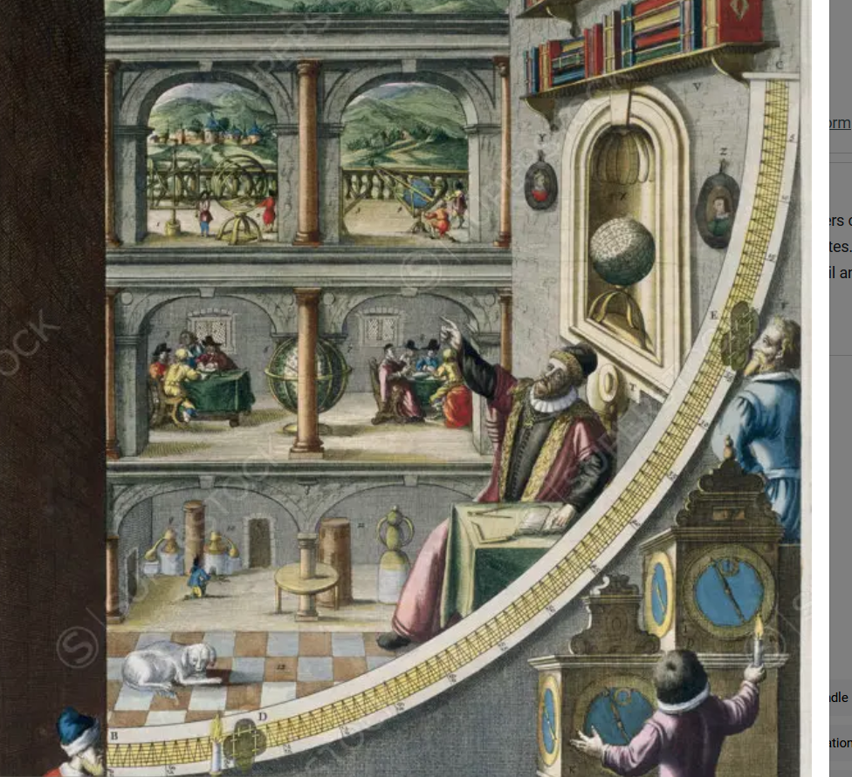
Superstock offers millions of photos, videos, and stock assets to creatives around the world. This image of Tycho Brahe And Others With Astronomical Instruments, 1587. "Le Quadran Mural" 1663 Blaeu, Joan(1596-1673 Dutch) Newberry Library, Chicago, Illinois, USA by Newberry Library is available for licensing today.
Tycho Brahe And Others With Astronomical Instruments, 1587. "Le Quadran Mural" 1663 Blaeu, Joan(1596-1673 Dutch) Newberry Library, Chicago, Illinois, USA

FRESCO,
MURAL= τοιχογραφια, mur (French)=τοιχος,
What is fresco mean in art?
A fresco is a type of wall painting. The term comes from the Italian word for fresh because plaster (σοβας) is applied to the walls while still wet. There are two methods of carrying out fresco painting: buon fresco and fresco a secco.
Π.Χ.Ταφος του Φιλλίπου (ΒΕΡΓΙΝΑ ΗΜΑΘΙΑΣ), …

The Quadrant, ΤΕΤΑΡΤΗΜΟΡΙΟ, ΕΞΑΝΤΑΣ,
https://www.cartahistorica.com/our-catalogue/curiosities/quadrant/,
The quadrant would have already been described by Claudius Ptolemeus (c. 100 – 160s/170s AD).
(ΣΧΟΛΙΟΝ. AI Overview. "160s AD" refers to
the decade from the year 160 AD to 169 AD, with "AD" (Anno Domini) meaning "in the year of the Lord" in Latin, marking years after the traditionally estimated birth of Jesus Christ, a system now often replaced by CE (Common Era) for neutrality. So, "160s AD" means the 10 years in the second century (160, 161, 162... up to 169) following the birth of Jesus, a period under the rule of Roman Emperors like Antoninus Pius and Marcus Aurelius.),

It is a navigation tool in the form of a wooden or bronze quarter of a circle. There were multiple types of quadrants. They helped to calculate a celestial body position, to determine the time and to record the latitude (πλατοσ). In the thirteenth century it was rewritten by John the Sacrobosco in Paris and Jacob ben Machir ibn Tibbon (also called Profatius) in Montpellier. The disadvantage of the quadrant is its instability in case of a moving ship, so the use of this instrument at sea was not so practical. The bigger the instrument, the more accurate its calculations will be. The illustrated apparatus has been built by Brahe in 1588, and measured 194 cm
Original title: Quadrans Magnus Chalibeus in quadrato etiam comprehensus, unaque Azimuthalis

The School of Athens, (Italian: Scuola di Atene), η ΦΙΛΟΣΟΦΙΑ,
https://en.wikipedia.org/wiki/The_School_of_Athens,
Joshua Cole and Carol Symes. Western civilizations : their history & their culture, p.iii, πρωτο εσωτερικο εξωφυλλο
Συνισταται να πατε στο ανωτερω λινκ, για καλλιτερη θεαση.
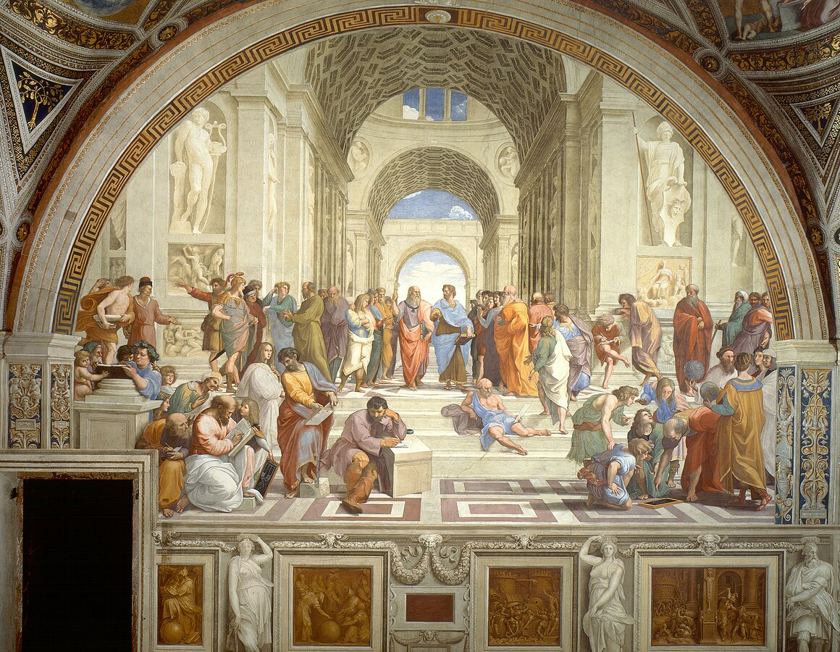
Artist Raphael SANTI,
Year 1509–1511
Type Fresco
Dimensions 500 cm × 770 cm (200 in × 300 in)
Location Apostolic Palace, Vatican City
https://en.wikipedia.org/wiki/Apostolic_Palace,
The Apostolic Palace[a] is the official residence of the Pope, the head of the Catholic Church, located in Vatican City. It is also known as the Papal Palace, the Palace of the Vatican and the Vatican Palace. The Vatican itself refers to the building as the Palace of Sixtus V, in honor of Pope Sixtus V, who built most of the present form of the palace.[2]
ΔΕΝ είναι το LATERAN PALACE

Who’s who in Raphael’s School of Athens?
https://aleteia.org/2017/05/24/whos-who-in-raphaels-school-of-athens,
Δεν είναι πληρως διαπιστομενο ΤΙΝΟΣ ΤΟ ΠΡΟΣΩΠΟ (πρωσοπικοτητα της τοτε ΙΤΑΛΙΑΣ, απεικονιζει τον ΦΙΛΟΣΟΦΟ η ΕΠΙΣΤΗΜΟΝΑ κλπ του ΠΙΝΑΚΑ
aleteia=αληθεια,

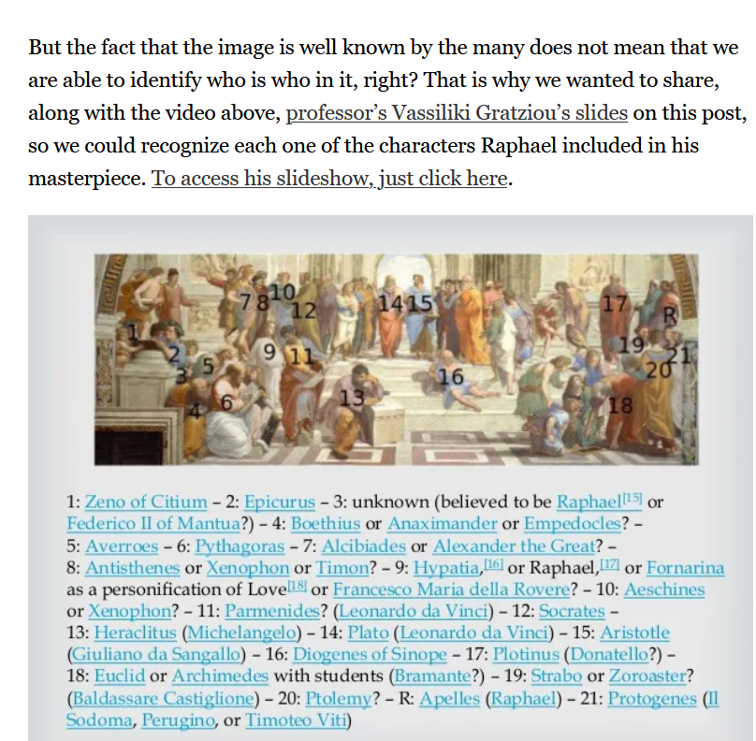
R, RAPHAEL,
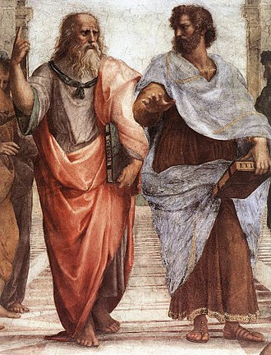
An elder Plato walks alongside a younger Aristotle.
ΤΙΜΑΙΟΣ κοσμολογιας, Ηθικα Νικομαχεια,

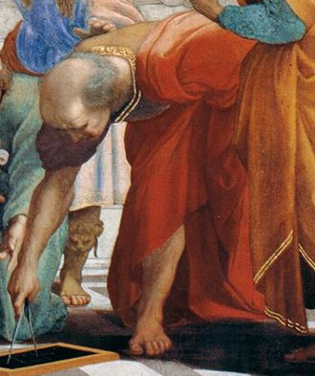
? Bramante as Euclid (ισως ΑΡΧΙΜΗΔΗΣ),
Donato Bramante
Donato Bramante (1444 –1514), born as Donato di Pascuccio d'Antonio and also known as Bramante Lazzari, was an Italian architect and painter.

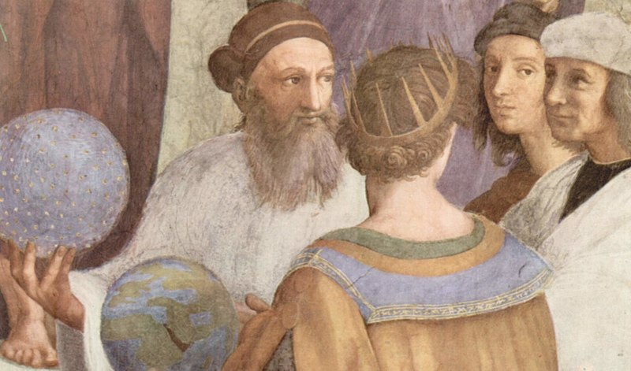
Zoroaster, Ptolemy, Raphael as Apelles, and Perugino Il or Sodoma or Timoteo Viti as Protogenes
Zoroaster,
https://en.wikipedia.org/wiki/Zoroaster,
Zoroaster,[a] also known as Zarathustra,[b] was a religious reformer and the spiritual founder of Zoroastrianism. He founded the first documented monotheistic religion in the world and also had an impact on Plato, Pythagoras, and the Abrahamic religions, including Judaism, Christianity, and Islam.[9][10][11] …
Date
There is no consensus on the dating of Zoroaster. The Avesta gives no direct information about it, while historical sources are conflicting. Some scholars base their date reconstruction on the Proto-Indo-Iranian language and Proto-Indo-Iranian religion, while others use internal evidence.[14] While many scholars today consider a date around 1000 BC to be the most likely,[7][8] others still consider a range of dates between 1500 and 500 BC to be possible.[2][3][4][5][6]

Η μοναδικη γυναικεια μορφη (9), θεωρειται ότι είναι η ΥΠΑΤΙΑ (HYPATIA). .
Averroes (Αβερρόης), ibn Rushd (1126 - 10 Δεκεμβρίου 1198)
ήταν Ανδαλουσιανός πολυμαθής Μουσουλμάνος, ειδικός στον Αριστοτελισμό, την ισλαμική φιλοσοφία, την ισλαμική θεολογία, τη σαρία, καθώς και τη νομολογία, τη λογική, την ψυχολογία, την πολιτική και την ανδαλουσιανή κλασική μουσική θεωρία και τις επιστήμες της ισλαμικής ιατρικής, αστρονομίας, γεωγραφίας, μαθηματικών, φυσικής και ουράνιας μηχανικής. Γεννήθηκε στην Κόρδοβα της Ισπανίας και πέθανε σε ηλικία 72 ετών στο Μαρακές.

Ο ΠΑΠΑΣ προβαλλει τον «ΠΑΓΑΝΙΣΜΟ» ?
Στον διασημο πινακα, που σημερα ονομαζεται ΣΧΟΛΗ ΤΩΝ ΑΘΗΝΩΝ προβαλονται διανοουμενοι ΕΘΝΙΚΟΙ η ΠΑΓΑΝΙΣΤΕΣ η ΕΙΔΟΛΟΛΑΤΡΕΣ κλπ. ο ΠΑΠΑΣ που πληρωσε για το εργο, τι λογο εχει να τους προβαλλει ?
ΠΑΡΑΤΗΡΗΣΕΙΣ,
Pope Alexander VI (c. 1431 – 18 August 1503)
1517 ΜΑΡΤΙΝΟΣ ΛΟΥΘΗΡΟΣ,

ΣΥΜΠΛΗΡΩΣΕΙΣ,
ΠΑΡΑΤΗΡΗΣΕΙΣ
ΗΡΟΔΟΤΟΣ, ΘΟΥΚΥΔΙΔΗΣ Δεν εμφανιζονται giati ? Μηπως Η ΙΣΤΟΡΙΑ δεν ?ειναι επιστημη ?
Οι ΑΙΣΧΥΛΟΣ, ΣΟΦΟΚΛΗΣ, ΕΥΡΙΠΙΔΗΣ σεν εμφανιζονται στο φρεσκο ΠΑΡΝΑΣΟΣ στην STANZA de la Signatura. Γιατι αυτο ? Δεν θεωρουνται αρκετα μεγαλοι ποιητες ?

Πτολεμαιοσ, Ptolemy, Claudius Ptolemy Claudius Ptolemaeus, ,
https://en.wikipedia.org/wiki/Ptolemy,
Claudius Ptolemy (/ˈtɒləmi/; Greek: Πτολεμαιοσ, Ptolemaios; Latin: Claudius Ptolemaeus; c. 100 – c. 170 AD)[1] was an Alexandrian mathematician, astronomer, astrologer, geographer, and music theorist,[2] who wrote about a dozen scientific treatises, three of which were of importance to later Byzantine, Islamic, and Western European science. The first is the astronomical treatise now known as the Almagest (Η Μεγιστη), although it was originally entitled the Mathēmatikē Syntaxis (or Mathematical Treatise, and later known as The Greatest Treatise. The second is the Geography, which is a thorough discussion on maps and the geographic knowledge of the Greco-Roman world. The third is the astrological treatise in which he attempted to adapt horoscopic astrology to the Aristotelian natural philosophy of his day. This is sometimes known as the Apotelesmatika (lit. "On the Effects") but more commonly known as the Tetrábiblos, from the Koine Greek meaning "Four Books", or by its Latin equivalent Quadripartite.
Unlike most Greek mathematicians, Ptolemy's writings (foremost the Almagest) never ceased to be copied or commented upon, both in Late Antiquity and in the Middle Ages.[3] However, it is likely that only a few truly mastered the mathematics necessary to understand his works, as evidenced particularly by the many abridged and watered-down introductions to Ptolemy's astronomy that were popular among the Arabs and Byzantines.[4][5]

Protogenes
https://en.wikipedia.org › ...·Protogenes από en.wikipedia.org
Protogenes was an ancient Greek painter, ( c. 4th century BC) a contemporary rival of Apelles. As with the other famous ancient Greek painters, none of his work has survived, ...

