08 μαθημα, 08 mathhma, 21-03-2026, σαββατο,
Webex meeting recording: 08 mathhma INM 2026-20260321 1713-1
Recording link: https://uoa.webex.com/uoa/ldr.php?RCID=cfb72de9628b4825c340ef7b965e7e05,
Password: yBVP2Trn

ΠΡΟΚΑΤΑΡΚΤΙΚΑ,
Κινητα τηλεφωνα

ΠΟΡΕΙΑ ΠΡΟΣ ΤΟΝ ΠΟΛΙΤΙΣΜΟ, (eng CIVILIZATION),

ΠΑΡΑΤΗΡΗΣΕΙΣ ΤΙΝΕΣ,

ΓΛΩΣΣΙΚΑ,
CIVILIZATION (USA), CIVILISATION (british), =ΠΟΛΙΤΙΣΜΟΣ.
Σχετιζεται με το ΠΟΛΙΣ.
CULTURE, ΚΟΥΛΤΟΥΡΑ,
Is it civilization or civilisation,
https://sapling.ai/usage/civilized-vs-civilised,
Civilized and civilised are both English terms. Civilized is predominantly used in 🇺🇸 American (US) English while Civilised is predominantly used in 🇬🇧 British English (used in UK/AU/NZ) ( en-GB ).
SGP. Συγκριση μεταξυ CIVILISATION, ΠΟΛΙΤΙΣΜΟΣ (ελλ).
Υπουργειο Πολιτισμου, Ministry of Culture,
https://en.wikipedia.org/wiki/Civilization,
The English word civilization comes from the 16th-century French civilisé ("civilized"), from Latin civilis ("civil"), related to civis ("citizen") and civitas ("The social body of the citizens united by law").
Latin word for "city" was urbs.[12]
CIVILIS. civic, civil (of or pertaining to citizens)
public, political (of or pertaining to public or political life)

TAXONOMY, ΤΑΞΙΝΟΜΙΣΗ ΖΩΩΝ,

Taxonomy (biology)
https://en.wikipedia.org/wiki/Taxonomy_(biology),
In biology, taxonomy (from Ancient Greek τάξις (taxis) 'arrangement', and -νομία (-nomia) 'method') is the scientific study of naming, defining (circumscribing) and classifying groups of biological organisms based on shared characteristics. Organisms are grouped into taxa (singular: taxon) and these groups are given a taxonomic rank; groups of a given rank can be aggregated to form a more inclusive group of higher rank, thus creating a taxonomic hierarchy. The principal ranks in modern use are
domain, kingdom, phylum (phylum = φύλο, δηλαδή φυλή), class, order, family, genus, and species.

SPECIES, ΕΙΔΟΣ, .
https://www.nature.com/scitable/definition/species-312/,
A biological species is a group of organisms that can reproduce with one another in nature and produce fertile offspring.

Human Taxonomic Classification:
Google Mamalia, https://www.google.com/search?q=mamalia&client=firefox-b-d&hs=yqd9&sca_esv=25dfd463629c044b&ei=dJA-afzLOIiMxc8P0_mE0QY&ved=0ahUKEwj81fC97ryRAxUIRvEDHdM8IWoQ4dUDCBE&oq=mamalia&gs_lp=Egxnd3Mtd2l6LXNlcnAiB21hbWFsaWFIAFAAWABwAHgBkAEAmAEAoAEAqgEAuAEMyAEAmAIAoAIAmAMAkgcAoAcAsgcAuAcAwgcAyAcAgAgA&sclient=gws-wiz-serp,
Domain (Ομαδα, Τομεασ): Eukaryota (Ευκαρυωτικα), (organisms with complex cells)
Kingdom (Βασιλειον): Animalia (animals)
Phylum (Φυλή): Chordata (Χορδοτα) (vertebrates (Σπονδυλωτα) with a backbone)
Class (Κατηγορια): Mammalia (Θηλαστικa) (mammals)
Order (Ταξις): Primates (πρωτεύοντα θηλαστικά), monkeys (Μαιμου), apes (Πιθηκοσ), lemurs, κλπ
Family (Οικογενια): Hominidae (Ανθρωπίδες), (great apes: orangutans, gorillas, chimpanzees, humans)
Σχολιο βασιλισης Βικτωριας. Δεν «προερχομεθα από «πιθηκους».
Genus (Γενος): Homo (Ανθρωποσ) (humans and extinct relatives, )
Αλλα ειδη του genus homo:
†Homo habilis (Άνθρωπος ο επιδέξιος)
mainly used tools in butchering
†Homo erectus (ΑΝΘΡΩΠΟΣ Ο ΟΡΘΙΟΣ)
†Homo antecessor (ΑΝΘΡΩΠΟΣ Ο ΠΡΟΔΡΟΜΟΣ)
Populations of this species may have been present elsewhere in Western Europe, and were among the first to colonise that region of the world, hence the name.
†Homo ergaster (ΑΝΘΡΩΠΟΣ ΕΡΓΑΤΗΣ),
reference to the more advanced tools used by the species in comparison to those of their ancestors.
†Homo heidelbergensis
†Homo floresiensis
that inhabited the island of Flores Indonesia, until the arrival of modern humans about 50,000 years ago.
…. Homo neanderthalensis
….
Species (Ειδος): Homo Sapiens (Ανθρωπος ο ΕΜΦΡΩΝ, ΣΟΦΟΣ κλπ), ) (modern humans)
Ανοικτο ερωτημα. Αγνωστον αν ο Homo Neanderthalensis ανηκει στο ιδιο ειδος με τον Homo Sapiens η ΟΧΙ. .
Αν ανηκουν σε διαφορετικα ΕΙΔΗ, τοτε απλα οι Ανθρωποι του Νεαντερταλ θα ειχαν ωσ ονομα ειδους ο Homo Neanderthalensis.Αυτο χρησιμοποιουμε προς ωρας. Τοτε εμεις λεγομαστε Homo Sapiens,
Αν ανηκουν στο ιδιο ειδος, τοτε εχουμε στο ΕΙΔΟΣ Homo Sapiens, Δυο ΥΠΟΕΙΔΗ. Οι ονομασιες θα ησαν Homo Sapiens Sapiens kai Homo Sapiens Neadertalensis.

Carl Linnaeus, 1707-1778, Σουηδία
The Swedish botanist Carl Linnaeus is regarded as the founder of the current system of taxonomy, as he developed a ranked system known as Linnaean taxonomy for categorizing organisms and binomial nomenclature for naming organisms.
BINOMIAL. Binomial expressions are common English phrases that include a pair of words usually joined by “and” or “or” (e.g. black and white, plain and simple, more or less). The order of the words is usually fixed, and they are a single chunk of English vocabulary
Λευτερια η θανατος, όλα η τιποτα, again and again, tried and tested, back and forth, bit by bit,

Taxonomic Classification of DOGS, ΚΥΝΕΣ,

Google: Taxonomic Classification of DOGS
Here is a detailed breakdown:
…Domain: Eukaryota (organisms with complex cells)
Kingdom: Animalia (Animals)
Phylum: Chordata (Chordates)
Class: Mammalia (Mammals)
Order: Carnivora (Carnivores)
Family: Canidae (Κυνίδαι) (Dogs, wolves, foxes, jackals)
Genus: Canis (Κυων)) (Dogs, wolves, jackals, dingo)
Species: Canis lupus (Gray wolf)
Subspecies: Canis lupus familiaris (Domestic dog),

INFO
Κυνοδοντες,
CARNIVORA, ΚΑΡΝΑΒΑΛΙ,
Domestic dog Οικοσιτος σκυλος. As the first animal to be domesticated (15,000-33,000 years ago) since then it has played an important role in the history of human civilization.

SPECIES, ΕΙΔΟΣ, .
https://www.nature.com/scitable/definition/species-312/,
A biological species is a group of organisms that can reproduce with one another in nature and produce fertile offspring.

Canine Family, ΟΙΚΟΓΕΝΙΑ ΚΥΝΕΙΔΕΣ,
Etymology. From Latin canīnus (“of dogs, dog-like”), from canis (“dog”). Compare French canin.
ΚΥΩΝ, παρεμφερες του CANIS
κληρονομημένο από την πρωτοϊνδοευρωπαϊκή *ḱwṓ. Συγγενή: σανσκριτική श्वन् (śván), λατινική canis (> γαλλική chien), αγγλοσαξονική hund, αγγλική hound

ΠΟΥ ΑΝΗΚΟΥΝ ΟΙ ΣΚΥΛΟΙ μασ,
Family (ΟΙΚΟΓΕΝΙΑ), Canine (ΚΑΝΙΔΕΣ η ΚΥΝΙΔΕΣ), (Dogs, wolves, jackals foxes,)
Genus (ΓΕΝΟΣ), Canis, (ΚΥΩΝ), (π.χ. λύκους, τα κογιότ, τα τσακάλια, τα ντίνγκο, τους σκύλους κλπ).
Species (ΕΙΔΟΣ), Canis lupus (The wolf (Canis lupus;[b] pl.: wolves), also known as the gray wolf or grey wolf,)
SubSpecies (Υπο-ΕΙΔΟΣ), Canis lupus familiaris (οικογενια) (τα συνηθη σκυλια),

INFO,
Lupus, (λυκος),
ΔΕΝ σχετιζεται με τα ΛΥΚΟΦΩΣ η ΛΥΚΑΥΓΕΣ,
File:Twilight description full day.svg
https://commons.wikimedia.org/wiki/File:Twilight_description_full_day.svg,
https://commons.wikimedia.org/wiki/File:Twilight_description_full_day.svg,
CYNIC, ΚΥΝΙΚΟΣ, . contemptuously distrustful of human nature and motives .
e.g. Franklin D. Roosevelt, “Those cynical men who say that democracy cannot be honest and efficient.”
Lupus latin for english wolf,
ΔΕΝ σχετιζεται με τα ΛΥΚΟΦΩΣ η ΛΥΚΑΥΓΕΣ,
File:Twilight description full day.svg
Lux latin (μτφ ΦΩΣ)
Homo is a Latin word that means man, or human.
Είναι διαφορετικο when it is used as a prefix, as in "homosexual,". Then it comes from the Greek word ομοιος, meaning “the same”.

ΣΥΝΟΨΙΣ,
Εμεις ειμαστε ειδος HOMO SAPIENS,
Τα σπιτικα ΣΚΥΛΙΑ είναι στο ειδος Canis lupus (gray wolf), και στο υποειδος Canis lupus familiaris,

«African origin" recent model,

ΔΙΑΡΚΕΙΑ ΥΠΑΡΞΗΣ ΣΥΜΠΑΝΤΟΣ
Age of the universe
https://en.wikipedia.org/wiki/Age_of_the_universe,
In physical cosmology, the age of the universe is the time elapsed since the Big Bang. Astronomers have derived two different measurements of the age of the universe:[1] a measurement based on direct observations of an early state of the universe, which indicate an age of 13.787±0.020 billion years (c. 14 billions) (εδώ για την ωρα αυτό δεχομαστε), as interpreted with the Lambda-CDM concordance model as of 2021;[2] and a measurement based on the observations of the local, modern universe, which suggest a younger age.[3][4][5]
ΔΙΑΡΚΕΙΑ ΥΠΑΡΞΗΣ ΓΗΣ
https://en.wikipedia.org/wiki/Age_of_Earth,
Age of Earth
The age of Earth is estimated to be 4.54 ± 0.05 billion years (4.54 × 109 years ± 1%).[1][2][3][4] (c. 4.5 billion) This age may represent the age of Earth's accretion, or core formation, or of the material from which Earth formed.[2] This dating is based on evidence from radiometric age-dating of meteorite[5] material and is consistent with the radiometric ages of the oldest-known terrestrial material[6] and lunar samples.[7]
ΕΜΦΑΝΙΣΗ ΖΩΗΣ,
Earliest known life forms,
https://en.wikipedia.org/wiki/Earliest_known_life_forms,
The earliest known life forms on Earth may be as old as 4.1 billion years old (or Ga) (c. 4 billions) according to biologically fractionated graphite inside a single zircon grain in the Jack Hills range of Australia.[2]

https://en.wikipedia.org/wiki/Recent_African_origin_of_modern_humans,
The history of civilization is a short one. Within the study of humanity, which reaches back to the genus Homo (ΑΝΘΡΩΠΟΣ), in Africa, some 1.7 million years ago, it is merely a blip on the radar screen.
Perlambaνει και τα καρακατω ειδη
†Homo habilis (Άνθρωπος ο επιδέξιος)
mainly used tools in butchering
†Homo erectus (ΑΝΘΡΩΠΟΣ Ο ΟΡΘΙΟΣ)
†Homo antecessor (ΑΝΘΡΩΠΟΣ Ο ΠΡΟΔΡΟΜΟΣ)
Populations of this species may have been present elsewhere in Western Europe, and were among the first to colonise that region of the world, hence the name.
†Homo ergaster (ΑΝΘΡΩΠΟΣ ΕΡΓΑΤΗΣ),
reference to the more advanced tools used by the species in comparison to those of their ancestors.
†Homo heidelbergensis
†Homo floresiensis
that inhabited the island of Flores Indonesia, until the arrival of modern humans about 50,000 years ago.
Homo neanderthalensis
Homo Sapiens
Homo sapiens, (οσον αφορα σωματικα χαρακτηριστικα), most likely developed in the Horn of Africa between 300,000 and 200,000 years ago,. Εχει τα δικα μας σωματικα χαρακτηριστικα.

https://en.wikipedia.org/wiki/Horn_of_Africa,
https://en.wikipedia.org/wiki/File:Horn_of_Africa_(orthographic_projection).svg,
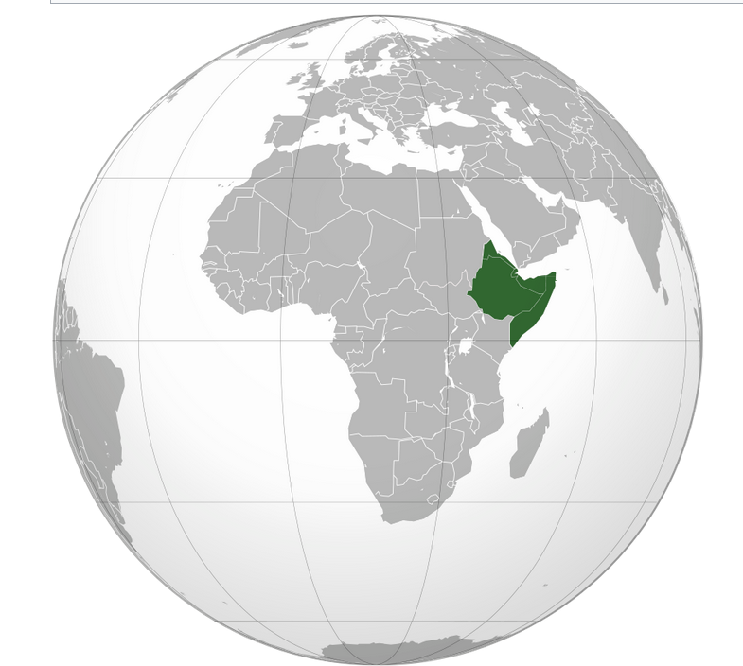

The "recent African origin" model proposes that all modern non-African populations are substantially descended from populations of Homo sapiens that left Africa after that time.
Homo sapiens dispersed from Africa in several waves, from possibly as early as 250,000 years ago, and certainly by 130,000 years ago,.
Behavioral modernity,
involving the development of language, figurative art (describes artwork particularly paintings and sculptures that is clearly derived from real object), and early forms of religion
abstract thinking, planning in depth, music and dance, exploitation of large game, and blade technology, (etc.) is taken to have arisen before 40,000 years ago,

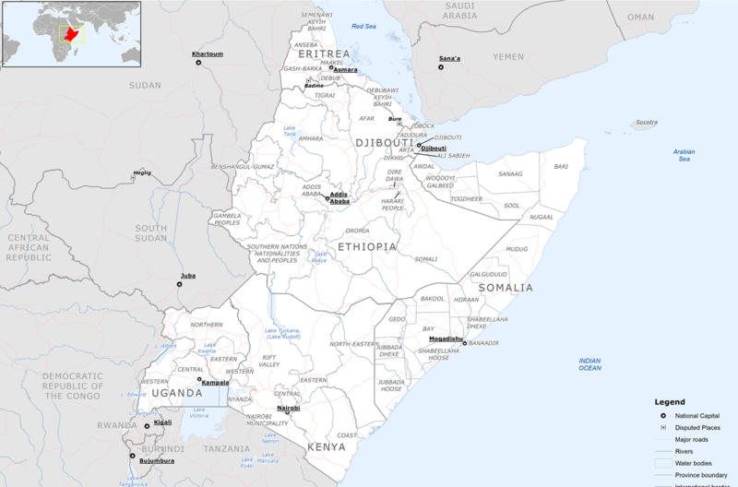
The Greater Horn of Africa consists of more than the typical four countries, including also Kenya, Uganda, Sudan and South Sudan.[23][24]
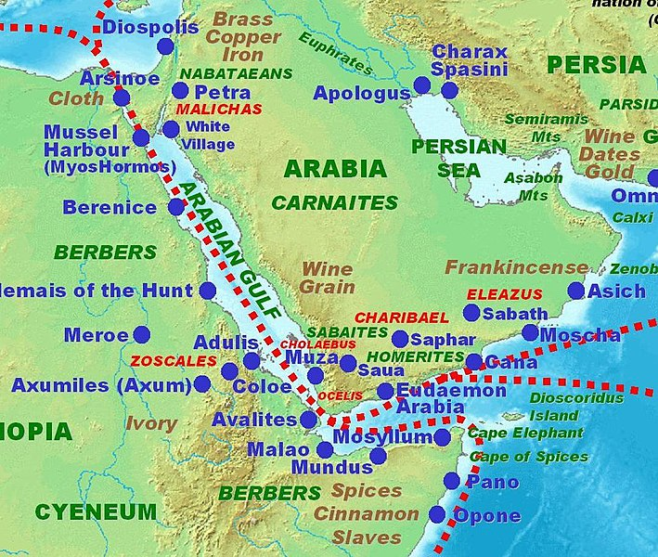
Ancient trading centers in the Horn of Africa and the Arabian peninsula according to the Periplus of the Erythraean Sea
INFO
ΕΡΥΘΡΑ ΘΑΛΑΣΣΑ, είναι ΕΡΥΘΡΩΠΗ λογω πλαγκτον κλπ
ΙΣΘΜΟΣ (eng isthmus).
Ο ισθμός είναι σχετικώς στενή λωρίδα εδάφους που χωρίζει δύο ακτές (συνήθως θαλασσών) και με τη σειρά του συνδέει δύο μεγαλύτερες περιοχές ξηράς. Μορφολογικά είναι το αντίθετο του πορθμού (eng strait), (ή γενικά του αμφίγειου), ο οποίος χωρίζει δύο περιοχές ξηράς.
Οι ισθμοί είναι από γεωγραφικής άποψης καλές θέσεις για να κατασκευαστούν διώρυγες («κανάλια»). Η Διώρυγα (canal) του Παναμά π.χ. συνδέει τον Ατλαντικό και τον Ειρηνικό Ωκεανό, με αποτέλεσμα να μειώνει αισθητά τον χρόνο πλεύσεως μεταξύ των ακτών ανατολικής και δυτικής Αμερικής.

05 ΔΙΑΛΕΞΙΣ 15-03-2025,
Τhn kyriakh 23-03-2025, συζητησις για εργασιεσ 1001KaratheodorySynenteukshTouEinstei,
1006Babel.docx,
1007SchoolOfAthensSexist.docx
Ανακεφαλαιωσις από , «African origin" recent model»

ΠΕΡΙΛΗΨΗΣ,
Family (ΟΙΚΟΓΕΝΕΙΑ), Hominidae (ΑΝΘΡΩΠΙΔΑΙ η ΜΕΓΑΛΟΙ ΠΙΘΗΚΟΙ)
Π.χ. άνθρωπο, χιμπατζίδες, γορίλες και ουρακοτάγκους.
GENUS(ΓΕΝΟΣ), HOMO (ΑΝΘΡΩΠΟΣ kai relatives)
(SPECIES) ΕΙΔΗ
Homo Sapiens (ανθρωπος ο σοφος η ο εμφρων)
Ιt is likely that Homo sapiens (anatomically modern humans) has been the only extant species of genus Homo.
ΧΡΟΝΙΚΗ ΕΞΕΛΙΞΗ,
Αρχη του ΣΥΜΠΑΝΤΟΣ.
Προ c. 14 δισ. ετη.
Δημιουργια ΓΗΣ.
c. 4.5 billions ετη.
Εμφανισης ΖΩΗΣ στην ΓΗ
Προ c. 4 δις. ετη.
ΓΕΝΟΣ ΑΝΘΡΩΠΟΣ,
Προ 1.7 millions ετη, στην ΑΦΡΙΚΗ.
HOMO SAPIENS,
Homo sapiens, οσον αφορα σωματικα χαρακτηριστικα, most likely developed in the HORN of Africa between 300,000 and 200,000 years ago,.
HOMO SAPIENS, Behavioral modernity,
Behavioral modernity, involving the development of language, figurative art (describes artwork particularly paintings and sculptures that is clearly derived from real object), and early forms of religion (etc.) is taken to have arisen before 40,000 years ago,

