TIMSS ΔΙΔΑΣΚΑΛΙΑ ΣΕ ΜΙΑ ΤΑΞΗ Β ΓΥΜΝΑΣΙΟΥ
ΣΤΗΝ ΑΜΕΡΙΚΗ
ΘΕΜΑ
ΔΥΝΑΜΕΙΣ
http://www.timssvideo.com/us3-exponents

Αυτό το μάθημα μαθηματικών επικεντρώνεται στις ιδιότητες των δυνάμεων. Το μάθημα έχει διάρκεια 50 λεπτά. Υπάρχουν 36 εγγεγραμμένοι μαθητές στην τάξη.

Οι μαθητές έχουν ήδη δουλέψει τα παρακάτω
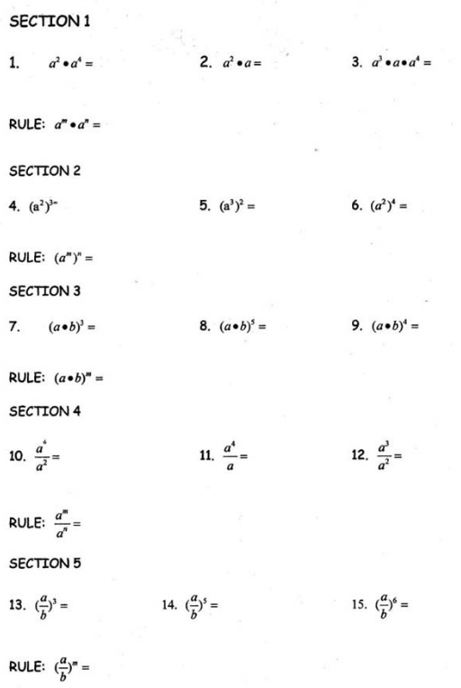
Στη συνέχεια τους ζητείται να αποδείξουν ότι (α⁰ = 1)
Highlight είναι οι ερωτήσεις της εκπαιδευτικού

Τι παρατηρείτε σχετικά με τον τρόπο που η εκπαιδευτικός προσπαθεί να υποστηρίξει τους μαθητές της - σε κάθε ομάδα - να αποδείξουν τη ζητούμενη μαθηματική σχέση;

ΟΜΑΔΑ 1
00:39:59 | You know, zero times everything is zero, right?
00:40:02 | Okay.
00:40:03 | Okay. But, if A equals one then... then- One times zero is zero. Like... never mind.
00:40:12 | You're not making much sense.
00:40:15 | Never mind. Ryan made it sound better.
00:40:16 | I always.
00:40:18 | Okay. Well, just think about your rules of division and multiplication that you just did.
00:40:24 | Work out some sample problems and see if you can come out and prove to me why A to the zero is one.
00:40:30 | A- Because A is one.
00:40:34 | No. A can be 10. And 10 to the zero power is one. A million to the zero power is one. Why is that?
00:40:43 | Think about using those rules.
00:40:46 | That like, just, went right over my head.
00:40:51 | Yes?
00:40:52 | Okay.
00:40:53 | Okay guys.

ΟΜΑΔΑ 2
00:41:37 | You guys, you're trying to think of terms in- things in terms of numbers.
00:41:41 | Think about putting your rules over here that we learned about, the adding and the- and the subtracting rules into-
00:41:50 | If you took variables- don't do numbers-
00:41:56 | M-A-B.
00:41:58 | How could you prove something is equal to one? What do we know about the rule of one?
00:42:04 | How are we gonna do these (inaudible). A by negative (inaudible).
00:42:05 | Think about that.
00:42:08 | Yes. You have a question?
00:42:09 | We never learned these. The negative ones. Remember. We never learned these.
00:42:13 | Oh, I know, but if you take the rules that you learned over here and think about that, you can make some examples.
00:42:22 | Using either your multiplication or your division rules up there that you developed.
00:42:27 | Let's see if you can come up with an example where that would be true

ΟΜΑΔΑ 3
00:42:32 | Hi. Since- Well, why do you have to multiply 'cause you didn't have to multiply it. Right? So it would just be one.
00:42:38 | Really? What if A was a million?
00:42:40 | Huh? A million?
00:42:42 | Yeah. Let's say our A was equal to a million.
00:42:43 | Oh, no. 'Cause it would be equal to six. Huh?
00:42:44 | A million and one.
00:42:47 | Equals six.
00:42:48 | How do you-
00:42:49 | And they- So six to the zero power is one.
00:42:50 | Yeah. And any-
00:42:52 | How?
00:42:53 | 'Cause anything is one.
00:42:54 | Well, that's what I want you to show me. How?
00:42:55 | But if it says like- like when you multiply something by zero it says you're not doing anything to the-
00:43:01 | Like if you had six times zero it says that you're not multiplying anything (inaudible) zero.
00:43:04 | Okay. But we're dealing- we're dealing with powers now.
00:43:07 | Yeah I know, but I don't- I don't see how it could make anything different.
00:43:08 | So it'd be A times C.
00:43:09 | Oh I know. 'Cause it's only one of these.
00:43:12 | That's what I was trying to say.
00:43:13 | Is that it? It's only one A because there (inaudible).
00:43:14 | You're getting- you're on the right track.
00:43:17 | 'Cause it's only one. It's not-
00:43:18 | Start thinking about it in terms of multiplication and division now.
00:43:20 | I know. I know. I know. I know. I know.

ΟΜΑΔΑ 4
00:43:39 | Does A to the zero mean A times zero?
00:43:41 | No.
00:43:42 | No it doesn't. What does it mean?
00:43:43 | A would have to be one then, right?
00:43:45 | No. 'Cause I can tell you that a million to the zero power is one.
00:43:47 | Oh. So A times- A times itself to-
00:43:50 | Ten thousand to the zero power is one.
00:43:53 | What?
00:43:54 | Over- Oh.
00:43:56 | Start thinking about it. You're getting there, Brandon. Start thinking about it.

