https://www.elon.edu/e-net/Article/143293

Media highlights Albright's expanded research on the spread of 'fake news'

Jonathan Albright, assistant professor of communications, has become a go-to source for reporters looking to understand the power of the "fake news" ecosystem.
Jonathan Albright's research to document how and where "fake news" spreads online and pull back the curtain on what drives its creation and appeal is continuing to gain notice from media outlets both domestically and internationally.
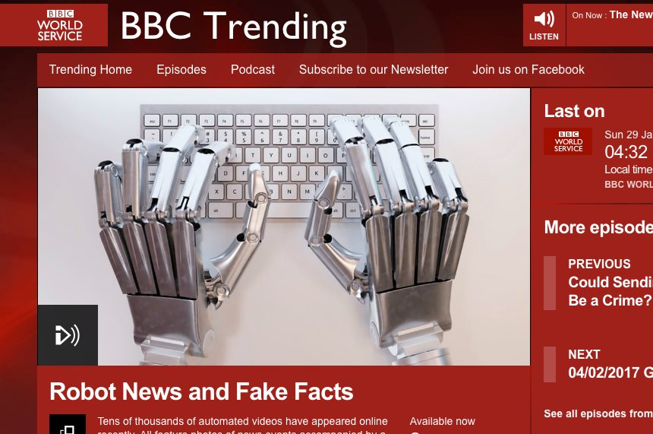enlargeAlbright was recently featured in an edition of BBC Trending, a technology program of the BBC.
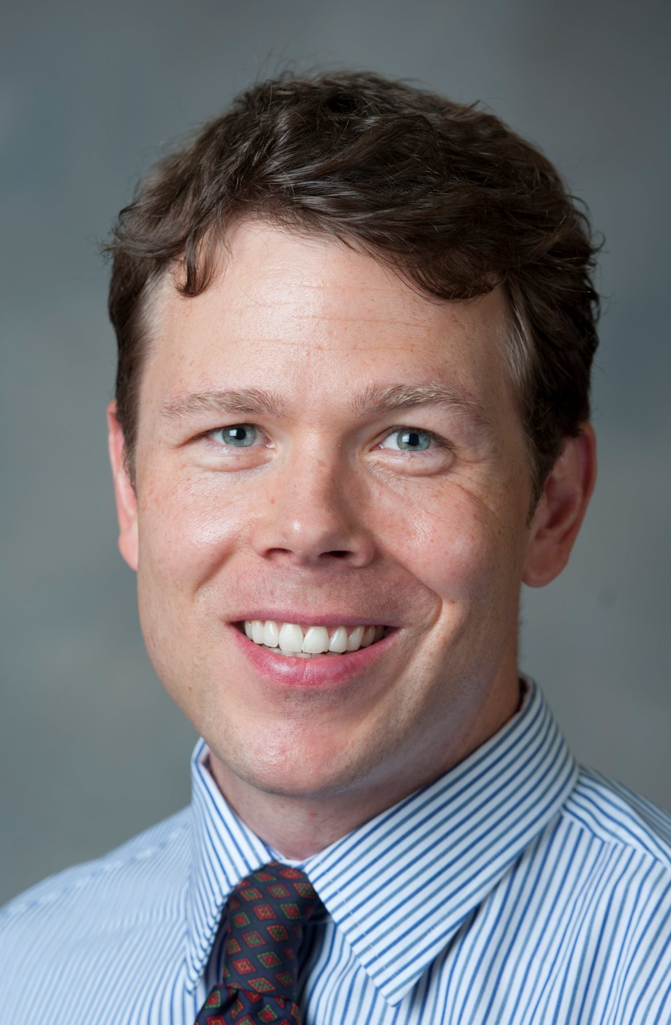enlargeJonathan Albright, assistant professor of communications​The increased mentions in the media come as Albright continues to report on his findings, with a recent piece published on the Medium platform that documents the spread of computer-generated videos on YouTube that appear designed to influence search engine results for a broad range of topics in U.S. politics and international relations.
In a Medium post titled "FakeTube: AI-Generated News on YouTube," Albright pointed to a mix of more than 80,000 videos he discovered on YouTube generated by artificial intelligence and then distributed by 19 various YouTube channels. The videos use as their scripts snippets of text from a variety of news outlets as well as "fake news" sources, and were crowded with keywords to help boost them in search results.
"It’s a little worrisome that YouTube either isn’t aware of this huge 'fake news' AI-generated video operation, or they’ve just chosen not to do anything about it," Albright wrote on Medium. "I feel this content machine is yet another factor that amplifies the “fake news” problem."
The research caught the attention of the BBC, with Albright featured by its BBC Trending program on Jan. 29 in a segment titled "Robot News and Fake Facts." Albright explained that the goal is not necessarily to rack up clicks, but to manipulate search rankings.
"It's a little frightening," Alright said. "It's just odd that something can synthesize different sections of new articles and then put it together and speak it out in a somewhat robotic voice."
Listen to the entire segment here.
Albright was also recently a featured guest on Capital Tonight, the nightly statewide public affairs program of TWC News, in a segment titled "Fake News and the Effect on Political Discourse."
Joined by Daniel Kriess, associate professor in the UNC School of Media and Journalism, Albright was asked about the role that social media plays in the spread of fake news, and noted that people sometimes self edit the sources they turn to for news to include just those adhering to their views. "I see Facebook and Twitter as amplifiers of fake news but I think that it's very difficult for people to get outside of that filter bubble (of social media) and go to websites that they could be opposed to ideologically."
Beyond being called on by the media, Albright's research has also generating interest from academia. He shared his research on Jan. 26 as the featured speaker at the 2017 DeAngelo Lecture at the University of Mary Washington in Fredericksburg, Virginia.

