http://www.newsweek.com/2016/12/02/robert-mercer-trump-donor-bannon-pac-523366.html

Meet Robert Mercer, the Mysterious Billionaire Benefactor of Breitbart
By Max Kutner On 11/21/16 at 9:59 AM

12/02/16

U.S.Donald Trump Stephen Bannon2016 Presidential Electiontrump transition

Updated | Robert Mercer seemed uncomfortable. It was 2014, and the billionaire had just stepped behind the podium to accept a lifetime achievement award at the annual meeting of the Association for Computational Linguistics. Dressed in a suit and tie, he warned his audience that speaking to them for the required hour or so was “more than I typically talk in a month” and that he was no longer in their field of work. “I left IBM Research 20 years ago, and I really have not paid any attention to the world of linguistics or to IBM since then. And I can’t really talk about what I do now.”
That might have been OK for the folks inside that grand ballroom at a Baltimore hotel, but what he does now is of vital interest to the rest of America, because he is the mysterious billionaire who wrote the checks that got Donald Trump elected president. Mercer was reportedly the third biggest donor to conservative outside-spending groups this election cycle, behind casino magnate Sheldon Adelson and hedge fund manager Paul Singer, and The Washington Post named him one of the “top 10 most influential billionaires in politics,” alongside Rupert Murdoch, the Koch brothers and President-elect Trump. But unlike those men, Mercer is by all accounts an extremely discreet individual who almost never gives interviews (his representatives would not put him in touch with Newsweek). As he once told The Wall Street Journal, “I’m happy going through my life without saying anything to anybody.”
Yet by giving millions to a conservative super PAC, Make America Number 1, which his daughter Rebekah chaired, Mercer seems to have bought more influence over Trump’s campaign than any other donor. Rebekah also has ties to Stephen Bannon, the controversial Breitbart News Network executive chairman who was recently named the new administration’s chief strategist and senior counselor, records show. A campaign ethics watchdog and a political group are now calling on the Federal Election Commission (FEC) and the FBI to investigate those connections because they believe the entanglements between the Mercers, the super PAC and the Trump campaign are illegal.
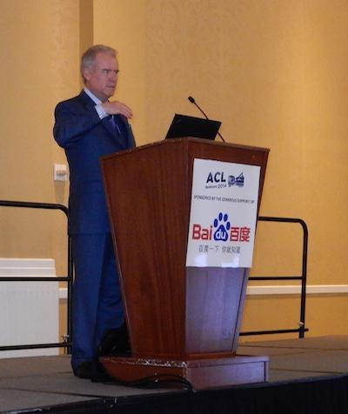
Robert Mercer received a lifetime achievement award from the Association for Computational Linguistics in 2014. The Association called his computer programming work "revolutionary." Association for Computational Linguistics

Million-Dollar Toy Trains
“I don’t usually talk about myself,” Mercer said in that 2014 speech, which may explain why there’s not much about him in the public record. He grew up in New Mexico, the son of a Canadian immigrant who worked in aerosol research. Roger McClellan, a family friend, recalls that Mercer’s mother enjoyed theater and the arts, and Mercer has said his father piqued his interest in computers—in high school, he wrote code and studied manuals. While enrolled at the University of New Mexico, he worked as a programmer at the nearby Air Force base.
“I really loved everything about computers,” he said in Baltimore. “I loved the solitude of the computer lab late at night, I loved the air-conditioned smell of the place, I loved the sounds of the discs whirring and the printers clacking.” He later got his Ph.D. and went to work for IBM in 1972. He and his colleagues there devised a way for a computer to use statistical formulas and algorithms to translate languages. The Association for Computational Linguistics has called their work “revolutionary.”
In 1993, months after both of his parents died, Mercer was recruited by investment management company Renaissance Technologies, based on New York’s Long Island. He became its co-CEO in 2010. This year, Forbes ranked him at No. 18 on its list of highest-earning hedge fund managers and traders, with $150 million in annual earnings. (His net worth is not publicly known.) Some of that money pays for his mansion on Long Island Sound, called the Owl’s Nest, and his 203-foot yacht, Sea Owl, which has a crew of 18, fingerprint-recognition keypads, a self-playing Steinway baby grand piano and a mural of a tree, carved from Peruvian mahogany, that spans several flights of stairs. It is estimated to be worth $75 million.
He has been in the news a few times for lawsuits. In the 1990s, his daughter Heather sued Duke University for allegedly violating Title IX, the federal law that prohibits schools from discriminating based on sex, when she was cut from the football team. (She won $2 million in damages.) In 2009, he sued the manufacturer of a model train set for allegedly charging him $2.7 million, claiming it should have cost about $2,000 less. A federal judge sent the case to a Michigan state court; Mercer won the case there.
In More Money Than God, a 2010 book about hedge funds, Sebastian Mallaby describes Mercer as “an icy cold poker player” and says a former boss once characterized him as an “automaton.” L. Brent Bozell, founder and president of the conservative nonprofit Media Research Center—Rebekah Mercer is a board member, and it gets a lot of money from the Mercer Family Foundation—says otherwise: “This is a guy who most of the time you see him has a smile on his face. He enjoys life.” Bozell also says Mercer is brilliant. “What will just blow you away is how smart he is…. You start listening on a conversation he’s having with someone else, and guaranteed within 60 seconds your mind is in some happy place because you have no idea what he’s talking about.”
If Mercer had been content to spend his fortune on just model trains and player pianos, the United States might have just elected its first female president. But the billionaire has been contributing to federal political committees since 1998, according to FEC filings, and began giving to super PACs in 2010, after the Supreme Court ruled in the Citizens United case that such committees could receive unlimited donations. Since then, he has given $36.8 million to super PACs.
Close to half of that PAC money—$15.5 million—went to Make America Number 1. When that super PAC was formed in April 2015 (as Keep the Promise 1), it backed Ted Cruz, but in June 2016 it changed names and candidates, shifting to Trump. At around the same time, one of its leaders, Kellyanne Conway, took on a major role in Trump’s campaign, as campaign manager. Some two months later, another leader of that super PAC, David Bossie, joined Trump too. Rebekah Mercer took over the super PAC. “When they get engaged in something, it’s in a big way,” says a person involved in Republican fundraising circuits. “They don’t do anything small.”
The Mercers don’t just support federal candidates. In 2014, the Mercer Family Foundation, a nonprofit Rebekah leads, awarded $18,300,979 in grants and contributions, according to financial filings. Those recipients include a few mainstream ones, such as the American Museum of Natural History and the Moving Picture Institute (Rebekah sits on the boards of both). But the majority of the foundation’s beneficiaries are conservative, even fringe groups: the Heritage Foundation (Rebekah is on the board there too), the Cato Institute, the Manhattan Institute (Rebekah is a board member) and Citizens United. Some advocate for limited government, free markets and “Judeo-Christian values.” Another is led by researchers who have denied that humans caused global warming.
Contacted by Newsweek, representatives for more than a dozen of these organizations either declined to comment about the Mercers or did not respond to requests to do so. The few people who did agree to speak insist that Mercer isn’t some nefarious political mastermind. “In the times I’ve met him, [I] never got any sense of his politics,” says Richard Muller of Berkeley Earth, which consists of a team of former global-warming skeptics. (They now concede it is real.) “We’ve always just discussed science.”
One of Mercer’s biggest and most intriguing investments was not in a nonprofit and does not appear listed anywhere—he gave at least $10 million to Breitbart News, according to someone involved in Republican fundraising circuits who asked that Newsweek not name him in order to protect his political relationships (he says he knows firsthand about the transaction). Bloomberg reported the money was invested in 2011.
This past August, Bannon left Breitbart to help run the Trump campaign and is about to assume a vital position in the administration. His appointment as a top aide has prompted widespread criticism, including accusations that he is a darling of misogynists, white supremacists and anti-Semites. Those critics point to Breitbart headlines during Bannon’s tenure, such as “Birth Control Makes Women Unattractive and Crazy,” “Bill Kristol: Republican Spoiler, Renegade Jew” and “Hoist It High and Proud: The Confederate Flag Proclaims a Glorious Heritage.” Responding to the criticism, Bannon told The Wall Street Journal that the accusations are “just nonsense.” He further told The Hollywood Reporter, “I’m not a white nationalist, I’m a nationalist.” A spokesperson for the presidential transition team did not respond to a request for comment.
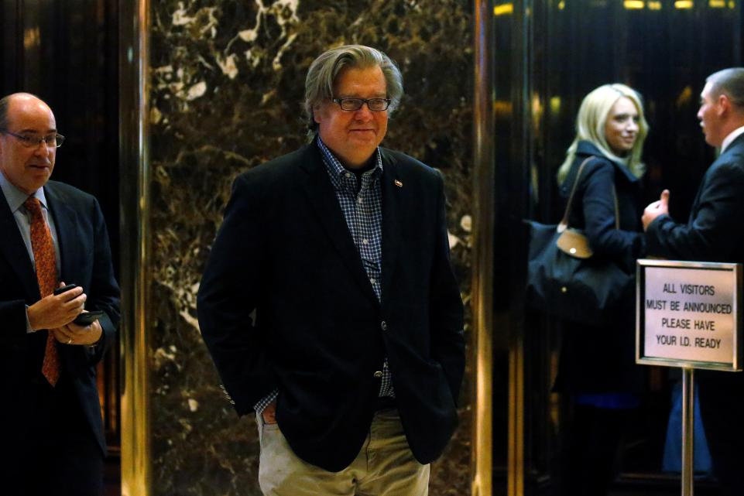Campaign CEO Stephen Bannon departs the offices of Republican president-elect Donald Trump at Trump Tower in New York, New York, November 11. Carlo Allegri/Reuters
Bannon critics can apparently blame Rebekah; she pushed Trump to bring him on board, the Republican fundraising insider says. Her ties with Bannon go back a few years or more. They served together as officers of at least two nonprofits, Reclaim New York and the Government Accountability Institute. They have also produced at least one documentary together, Clinton Cash, a fearmongering look at the Clinton family’s finances. It was also Rebekah who convinced Trump to hire Conway, according to the fundraising insider. “She is like her dad,” says the Media Research Center’s Bozell. “She understands issues, she understands people, she has a very good read on what’s real and what’s BS.”
Rebekah, Conway and Bossie (who produced another documentary with Bannon and reportedly with Rebekah, Torchbearer, about Duck Dynasty star Phil Robertson, and who led Citizens United, which received Mercer Family Foundation money) are now all on Trump’s transition team. “They look for talent, they rely on advice of friends, and they are very good to their friends,” Bozell says. The Republican fundraising insider says Rebekah is the one making these decisions. “Bob follows her lead,” the insider says. “He allows her to be the one who does the research, the one who asks the tough questions.”

Still Draining the Swamp?
The entanglements involving the Mercer family, the Make America Number 1 super PAC and the Trump campaign are confusing. They may also be illegal. In a complaint to the FEC, the Campaign Legal Center, a nonpartisan, nonprofit organization that defends campaign ethics, alleged in October that the Trump campaign paid Bannon and Conway illegally by funneling money to them through Make America Number 1. FEC records show that after the pair joined the campaign, the PAC gave money to Conway’s polling company and to Glittering Steel, a film production company Bannon is affiliated with. (He is said to run the elusive company and wrote and produced two of its films, Clinton Cash and Torchbearer.)
According to the Campaign Legal Center, there are no records showing that Bannon or Conway received money from the Trump campaign in the first few weeks they were working for it—but $247,000 from the super PAC did go to Conway’s company during that time, and $15,000 went to Glittering Steel about a week before Bannon joined. The Campaign Legal Center also alleges that the Trump campaign’s hiring of Conway and Bannon violated FEC rules because of their affiliations with Make America Number 1. The center further alleges that the super PAC’s and the Trump campaign’s use of data company Cambridge Analytica—in which Mercer has invested—was also a conflict of interest.
“Super PACs by law are supposed to be independent of the candidates that they’re supporting, and that’s clearly not the case here,” says Brendan Fischer, associate counsel at the Campaign Legal Center. The overlap seems to go beyond typical Washington, D.C., corruption, he adds. “Thanks to a dysfunctional FEC, you’ve seen super PACs working more closely with candidates.... But what the Trump campaign has done with Make America Number 1, and the relationship between Trump and the Mercer family, does seem to be without precedent in modern elections.”
In an email to Newsweek, Hogan Gidley, a spokesman for the PAC, denied the allegations. “The complaint is filled with falsehoods and misinformation,” he wrote. “Mr. Bannon never was associated with [Make America Number 1].” As for the use of Conway’s company and Cambridge Analytica, Gidley wrote, “At each company, procedures are in place to allow it to work for multiple clients as allowed in the law.” A Trump campaign spokesperson did not respond to Newsweek’s request for comment.
The FEC complaint could result in a monetary penalty—if its six commissioners decide to investigate, which Fischer says they rarely do. That could be why the Democratic Coalition Against Trump, part of the super PAC Keep America Great, is pursuing criminal charges instead of an FEC wrist slap. The coalition said in a November 15 statement that it had reported Bannon to the FBI over his allegedly receiving PAC money during the course of the campaign. The full amount from the super PAC to Glittering Steel was $950,090. “What we uncovered was almost a million dollars’ worth of payments that went to Bannon’s company,” the coalition’s Scott Dworkin tells Newsweek. “That in its own right is a felony.” (In his response, Gidley reiterated that Bannon was not associated with the super PAC.)
With Rebekah Mercer, Conway and Bossie on Trump’s transition team, and Bannon in a top administration role, the Mercer family’s influence now extends deep into the White House. This could be seen as contrary to some of Trump’s campaign rhetoric, such as when he vowed “to fight for every person in this country who believes government should serve the PEOPLE—not the donors,” called super PACs “total scams” and “very corrupt,” and slammed his opponent for receiving money from “hedge funders.” In January, he even criticized Ted Cruz for receiving “$11M from a NY hedge fund mogul,” precisely the amount Mercer had given Make America Number 1 at that point in its previous iteration.
By giving millions to get Trump elected, what did the self-made billionaire hope to get in return? Hillary Clinton proposed a tax on high-frequency trading of securities, which is reportedly a favorite of Renaissance Technologies. A Senate subcommittee has even questioned the company about its use of the tactic. The conservative-leaning advocacy group Americans for Tax Reform had said Clinton’s proposed tax would “burden markets by discouraging trading and investment,” and experts from the Urban-Brookings Tax Policy Center estimated that such a tax could cost finance companies $185 billion over 10 years. Carrie Levine of the Center for Public Integrity points out that Mercer has previously put money behind opponents of candidates who supported that type of tax.
Bozell insists that the Mercers have no motive besides patriotism and that they fall outside of any D.C. oligarchy. “When you’re a billionaire or a multibillionaire, you really don’t need anything,” he says. “These people are driven by what they believe is good for the country.”
This article has been updated to include two quotes from Stephen Bannon, which were unavailable before deadline.

