HAPPINESS AND SUSTAINABILITY AROUND THE EARTH
24-HOUR WEBINAR ON 22nd APRIL 2020
Meeting 03/04/2020

Chair: Prof. Phoebe Koundouri, AUEB, co-chair UN SDSN Greece, pkoundouri@aueb.gr
Speakers:
- Prof. Andreas Papandreou, NKUA, co-chair UN SDSN Greece, andreas.papandreou@unsdsn.gr
- Prof. Nikitas Pittis, University of Piraeus, npittis@unipi.gr
- Prof. Stelios Virvidakis, NKUA, Epistemology and Ethics, Philosophy and Theory of Science and Technology, svirvid@phs.uoa.gr
- Prof. Vasso Kindi, NKUA, 20th Century Analytical Philosophy and Philosophy of Science, vkindi@phs.uoa.gr
- Prof. George Pagoulatos, AUEB, European Politics, gpag@aueb.gr
- Prof. Nikos Theodossiou, Aristotle University of Thessaloniki, chair UN SDSN Black Sea , niktheod@civil.auth.gr

Moderator: Lydia Papadaki, manager UN SDSN Greece

Find more at: https://www.unsdsn.org/24hour-webinar
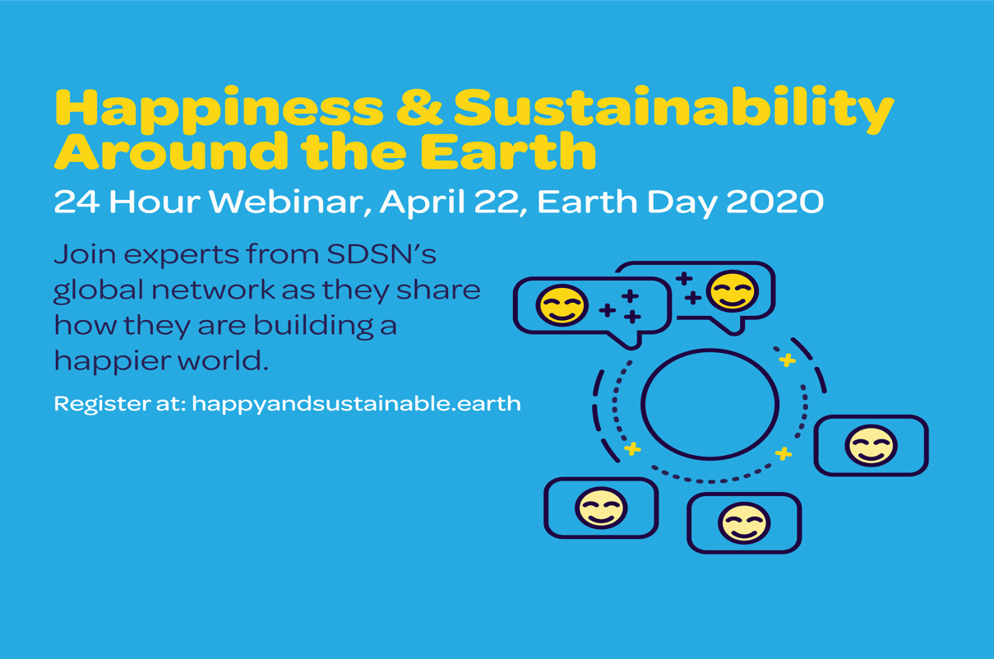
Register at our session (second session): https://register.gotowebinar.com/register/1600947610246201102?source=SDSN+Website
Session 2 – SDSN Greece, 11am EEST (90 minutes)

Topic: “Inclusive and sustainable economic growth and human well-being”

World renowned academics and international practitioners from the fields of philosophy, politics, economics, finance, engineering and innovations-related systems analysis, will navigate the waters of the relationship between Sustainable Development and Happiness, in an exciting session searching answers to the following questions: What are the main subjective and objective components of happiness? How is morality related to happiness? How is well-being to be understood? What are the weaknesses of GDP as a measure of well-being? What are the failings of methodological individualism? What is the role of political factors, global multilateral institutions, liberalism, European integration? What is the role of financial markets? How is the protection of the environment related to sustainable growth and human well-being? Answering these questions naturally leads us to face our fear! Can the transition to Sustainable Development happen with incremental changes? In the light of the COVID-19 health crisis and the many other crises that our generation is living through (the financial crisis 2007-08, the European debt crisis, the climate crisis) we will discuss whether what is needed now is a fundamental transformation of economic, social and financial systems that will trigger exponential change in strengthening social, economic, health and environmental resilience. Do we need big thinking and big changes? If yes, then system innovation and transitions thinking can help, and both call for intense public participation in the design of a common sustainable vision and the development of a transformation pathway of its implementation. Join us! We expect that your interventions will co-design the concluding remarks of the session!

Notes for the panelists:

- 90 minutes (11.00-12.30 Greek time)
- Language: English
- Tool: Go to Webinar (https://www.gotomeeting.com/en-ie/webinar)
  - for mac: https://support.goto.com/meeting/help/steps-for-installing-on-macs-g2m050005?c_prod=g2m&c_name=mktg
  - for windows: https://support.goto.com/meeting/help/steps-for-installing-on-windows-g2m050019?c_prod=g2m&c_name=mktg&_ga=2.202002583.745103447.1585918073-1646709604.1579073337
- How do I connect? You will receive an invitation to connect by SDSN Global. Click on the link.
- Each one responds to one question (4-5 minutes) or some question can be addressed by more than one speaker.
  - In total 1 hour for the discussion (2x5 minutes each speaker)
- Phoebe links the different aspects & questions
- Cameras (max capacity of 6 cameras on per time)
  - At the beginning all cameras on for greeting and 1st set of questions
  - Then, all cameras of the panelists off and we keep only on the cameras on of Phoebe and of the speaker
- Q&A at the end of the session based on questions raised by the audience

Structure

10.45 | Greek panel + moderator join 15 minutes in advance
11.00 -11.10 | Jorge wraps up previous discussion, introduces the session, SDSN Greece and the moderator  Lydia to introduce the concept and launch polls and Phoebe  “We will be talking on…. Don’t forget! There is a Q&A at the end, please add them in the chat box”
11.10-12.10 | Phoebe to introduce herself and the panelists. Phoebe addresses the questions to the panelists  (Lydia to deal with technical issues and shorts out the questions and shares with Phoebe)
12.20-12.30 | Q&A with each speaker  Lydia “thank you for joining us, you can find more on our site…”

Polls

Lydia Papadaki: Mapping of the audience – questions

Beginning
(raise your hand)
- What sector do you work in?
  - Public/private/academia/student/NGO
- Who has heard of the SDGs?

(polls)
- Do you consider yourself a happy person?
  - Yes/No
- Let us know where you are calling from
  - 5 regions (Europe, America, Africa, Asia, Australia)

End
(raise your hand)
- Did you enjoy the session?

Discussion

Phoebe Koundouri:

I will discuss the connection between the current health crisis with environmental and socio-economic crisis and the systemic change needed for the world to embark on a sustainable pathway that will be resilient to various forms of crises. Systems Innovation will have a major role to play. See my recent article for public press on this: https://www.unsdsn.org/never-waste-a-good-crisis-for-a-sustainable-recovery-from-covid-19

Stelios Virvidakis:
- What are the main subjective and objective aspects/components of happiness?
- To what extent do people in different societies/cultures diverge in their understanding of happiness?
- How is morality related to happiness?

Andreas Papandreou:
- What are the weaknesses of GDP as a measure of well-being?
- What are the strengths and weaknesses of the preference-based approach to well-being that has dominated economics?
- What is the relationship between individual and social wellbeing? Or what are the failings of methodological individualism?

George Pagoulatos:

- What is the importance of cultural and value factors such as trust?
- What is the relevance of political factors? Global multilateral institutions; liberalism vs illiberalism; European integration

Nikos Theodossiou:

- How is the protection of the environment related to sustainable growth and human well-being?
- Why is it important to identify the renewability of natural resources as a measure of establishing sustainable growth and human well-being?
- Why is ensuring the operation of infrastructure important for human well-being?

Vasso Kindi:

- How is well-being to be understood? Objective and subjective assessments and their implications.
- Is the distinction between zōē (life) and bios relevant to the assessment of well-being?
- Can/should the promotion of well-being trump rights?

