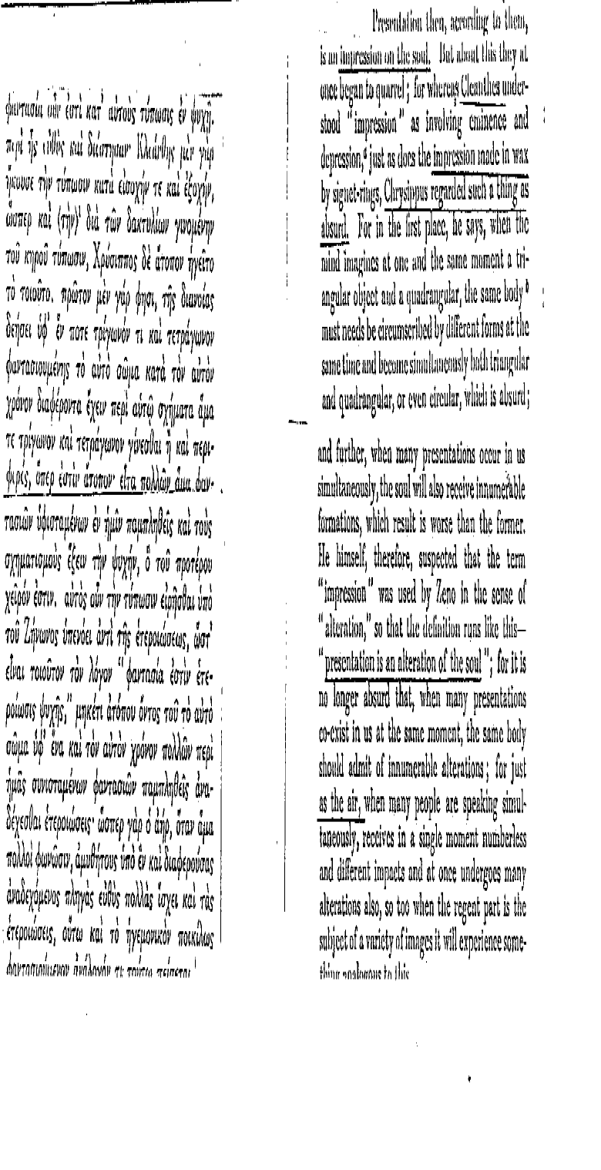
Sextus Empiricus, M 7.228–31

Sextus Empiricus, M 8.151–5
