Elements of Fregean Logic
Doukas Kapantaïs
(winter semester 2025-26, MA Logic)

The Innovations of Gottlob Frege’s Ideography

According to a well-known remark by Immanuel Kant, the part of philosophy that the Stoics called “Logic” had made, from the days of Aristotle up to his own time, scarcely a single step of progress. This remark is usually invoked by proponents of so-called “mathematical,” or “symbolic,” logic both as evidence of the alleged static character of the discipline prior to Frege and as a criterion for its progress from Frege onward.

I. Historical Remarks and Clarification of Terms
Many hold that modern logic was born in 1879 in Jena, Germany, when the then young mathematician Gottlob Frege published his now famous Ideography. However extreme this view may sound, it nonetheless brings out the magnitude of his achievement. This work introduces an almost entirely new way of treating argumentative forms, of which classical Aristotelian syllogistic may be regarded as a subset. The innovations are many and significant. We shall survey the most important of them, but only after first undertaking certain terminological and historical clarifications.
i) The symbolism of the Ideography, although it constitutes the foundation of modern logic, is no longer in use. The symbolism employed today is an evolution of that of the Italian mathematician Giuseppe Peano, as well as of that developed by Bertrand Russell and Alfred North Whitehead. Nevertheless, both the logic of Russell and Whitehead and contemporary symbolic logic follow, in most respects, the guiding lines laid down by the Ideography. Although neglected by its contemporaries, the Ideography, by a curious coincidence, was common intellectual property among those philosophers who later laid the foundations of Logical Positivism and Logicism. Russell and Whitehead studied it and introduced it into the Anglo-Saxon world at a time when the dominant philosophical current there was the Neo-Hegelianism of F. H. Bradley. Ludwig Wittgenstein attended Frege’s seminars on his new language; indeed, it was Frege himself who urged the young Wittgenstein to study logic under Russell. Rudolf Carnap had also attended these seminars. Finally, it should be noted that Frege never ceased teaching logic exclusively on the basis of the symbolism of the Ideography. Toward the end of his life, he even notes in his personal diary that, were he to ask himself what the outcome of his life’s work had been, the answer would be: “the essential part points to the Ideography.”
ii) At a few, but very specific, points Frege himself revises his views concerning symbolism over time. The most substantial of these concerns the use of the equality sign. Whereas in the Ideography he takes it to express what he himself calls the “identity of content,” after the composition of the essay “On Sense and Reference” and the articulation of that distinction, he takes it to express identity of reference. For example, in the Ideography the well-formed formula
——— A ≡ B
means that the sense-content of A is identical with the content of B. In the Grundgesetze der Arithmetik, by contrast, the well-formed formula
——— A = B
means that the reference of A is identical with the reference of B. The changes brought about by the discovery of the distinction between sense and reference are the most significant ones as far as the symbolism of the Ideography is concerned.
iii) The establishment of this classical Fregean distinction is also connected with a second innovation of the Grundgesetze der Arithmetik in relation to the Ideography. Function symbols (“Φ(ξ)”, “Ψ(ξ)”, etc.) are now regarded as proper names whose reference is the course of values (Wertverlauf) of the arguments for which the function is satisfied. In contemporary set-theoretic terms, one would say that the reference of a function symbol is the set of objects for which it is true. In the Grundgesetze this set is symbolized as follows: for example, for the function Φ(ξ) it is the course of values ἐΦ(ε), for the function Ψ(ξ) the course of values ἀΨ(α), and so on. It should be noted here that this latter innovation of the Grundgesetze is also connected with the fifth axiom of the same work, which became the target of Russell’s paradox.
iv) The Ideography constitutes perhaps the most sui generis case of a treatise in the history of logic. From what we learn from his notebooks, Gottlob Frege began to concern himself with what his contemporaries were doing in the same fields only after the completion and publication of the Ideography. And these contemporaries were not few: Bernard Bolzano, Giuseppe Peano, Ernst Schröder, among others. On the other hand, the reception accorded to this work by the scientific community ranged from lukewarm to outright negative. A few brief and largely critical reviews appeared in various journals, and it was not until 1903—the year in which Bertrand Russell published The Principles of Mathematics, where he presents and evaluates at length the work of his colleague—that the Ideography began to acquire the prestige it enjoys today.
v) The rendering of the German term Begriffsschrift has posed difficulties for translators. For reasons of brevity, it is rendered here as “Ideography,” although it bears no relation whatsoever to so-called “ideograms” or ideographic languages. As is clear both from the subtitle of the work and from what Frege himself says in the Introduction, this new “formal” language aims to disclose the “conceptual content” (begrifflicher Inhalt) of propositions and, accordingly, to “write” or “represent” that very content. Consequently—and given that the Greek term for “idea” is polysemous—it might perhaps be more accurate to translate it as semantic or conceptual symbolism.
vi) The motive behind the conception and composition of this conceptual language was the grounding of mathematics upon purely logical laws. From this perspective, both the Ideography and the later Die Grundlagen der Arithmetik, and of course the Grundgesetze der Arithmetik, have a pronounced anti-Kantian character. It should be recalled here that, according to Immanuel Kant, mathematical propositions as a whole are indeed true a priori but are nevertheless “synthetic.” This means that, although experience is not required for their verification, these propositions are not tautologies. The reason why they are independent of experience despite not being tautological is located in a function of consciousness that is not a logical law, namely a priori intuition (or intuition). By contrast, according to Gottlob Frege, the totality of mathematical propositions (with the exception of geometry) is grounded in “pure thought” and is tautological, that is, analytic. Already the Ideography is manifestly inspired by this vision of the logical foundation of mathematics, a project that would be completed in the Grundgesetze. Only toward the end of his life, and after the discovery of the paradoxes, did Frege begin to harbor doubts concerning the tautological character of the propositions of analysis, and to seek solutions that appeal to intuition, akin to those that ground geometry.
vii) As regards the necessity of conceiving and employing a new technical language, Frege explains—and justifies—it in two ways. First, he points out that the ambiguities of everyday language constitute an obstacle to the language of science. The reasons are obvious: if ambiguous terms occur in the premisses of an argumentative form, then the conclusions will likewise be ambiguous. The second reason is that the productive argumentative forms of everyday language are elliptical, and for this reason one can easily be misled and draw erroneous conclusions from true premisses, or conversely. A detailed registration of all the stages of an argument eliminates this danger. According to a metaphor that has become famous, everyday language is the eye, whereas the Ideography is the microscope.

II. The Basic Characteristics of the Ideography
In this part we shall set out the aims and the basic characteristics of the Ideography, placing particular emphasis on those features that made it the first treatise of “mathematical logic.” Our focus, that is, will be on why the logic of the Ideography constitutes an innovation with respect to classical Aristotelian logic.

i) Basic symbols
The expression
— A
means that “A” has judgable (or assertoric) content (beurteilbarer Inhalt). This, in turn, means that we can either affirm it or affirm its negation. The expression
⊢ A
means that we affirm its content. Frege calls the horizontal stroke the “line of conceptual content” (begrifflicher Inhalt) and the vertical stroke the “line of judgment” (Urteil). According to his example,
⊢ unlike magnetic poles attract one another
means that we affirm that unlike magnetic poles attract one another, whereas the expression
— unlike magnetic poles attract one another
represents precisely that which is affirmed. Finally, the expressions
⊢ ¬ (unlike magnetic poles attract one another)
and
— ¬ (unlike magnetic poles attract one another)
mean, respectively, that we affirm the negation of the claim that unlike magnetic poles attract one another, and that which is affirmed in doing so.

ii)
In §5, foreshadowing the technique of truth tables, Gottlob Frege clarifies that if A and B have judgable content, there are four possible cases with respect to the distribution of truth-values:
(a) A is affirmed and B is affirmed;
(b) A is affirmed and B is denied;
(c) A is denied and B is affirmed;
(d) A is denied and B is denied.
He then introduces the following configuration
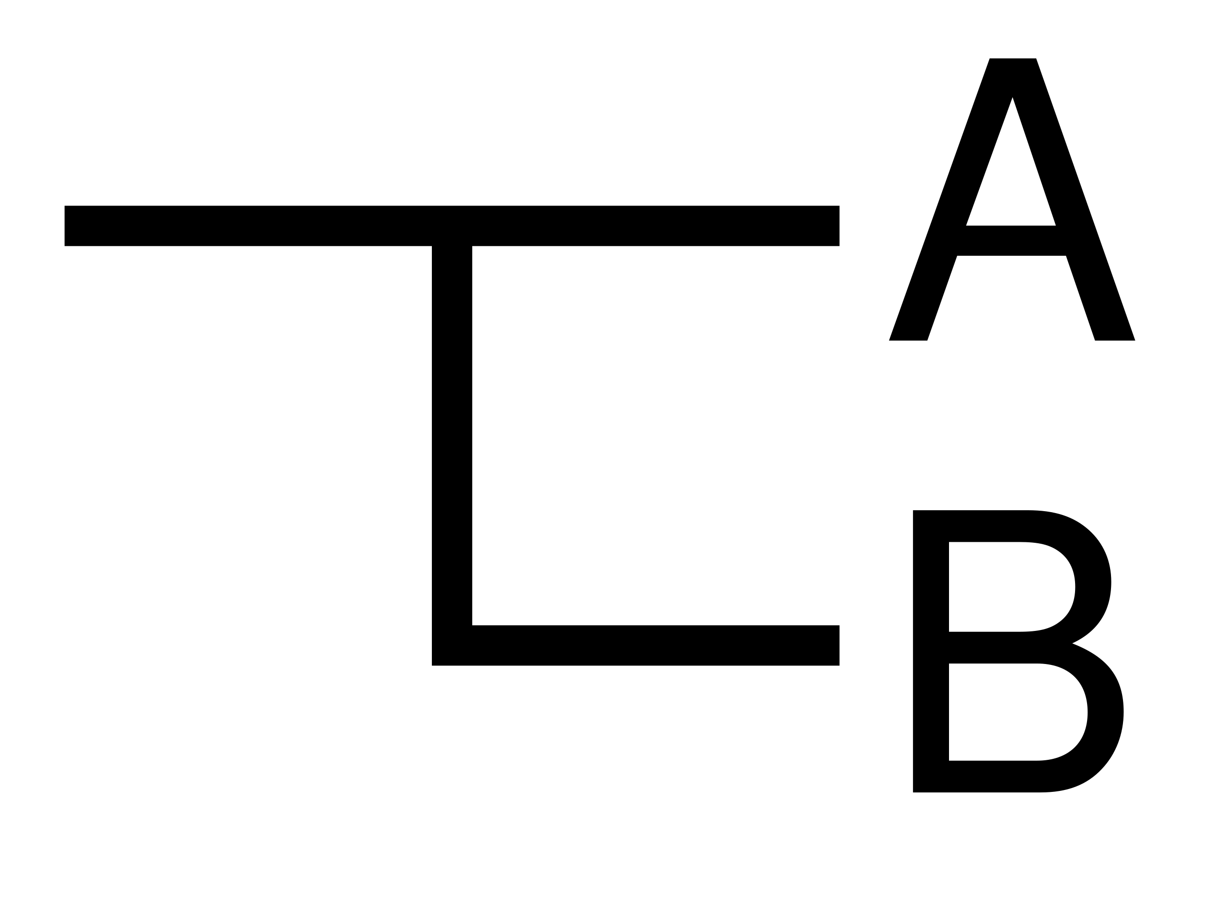
and defines it as follows: the expression signifies that the third case does not obtain. It is clear that what is at issue here is material implication. This form means “if B, then A,” under the condition that the proposition is false only when “B” is true and “A” is false. In contemporary symbolism it is rendered as “B → A.” This is perhaps the most important symbol of the Ideography, and it marks a decisive point of departure from the inferential resources of classical logic as developed by Aristotle.

iii)
In the system of the Ideography, there are only two rules of logical inference. One of them, although used extensively, is nowhere explicitly mentioned—evidently Frege regarded it as self-evident. The first is the well-known modus ponens. Having set out in §5 the first formulation in the modern history of logic of material implication—according to which the only case in which a proposition of the form “if B, then A” is false is when “B” is true and “A” is false—Frege proceeds in §6 to what follows as a matter of course. If we know that “if B, then A” is true, and also that “B” is true, then we may infer that “A” is true as well. Otherwise, “if B, then A” would turn out to be false, which would contradict the premisses. Indeed, explicitly comparing himself with Aristotle, Frege writes:
“From Aristotle onward, a whole series of rules of inference have been listed. I use only one, at least insofar as cases are concerned in which a new judgment (Urteil) is inferred from more than two others.”
The second rule of logical inference, which is likewise employed without being named, is the so-called rule of substitution. This rule guarantees that we may infer a proposition from a true proposition containing variables, provided that we uniformly substitute one or more variables with an argument. This rule is formulated explicitly in axioms 9–12 of the Grundgesetze der Arithmetik.
For someone familiar with contemporary methods of natural deduction, the parsimony of the inferential rules of the Ideography may appear puzzling. It must be emphasized, however, that the inferential system of the Ideography (as well as that of Principia Mathematica) is axiomatic. The rules are supplemented by a series of axioms whose truth is taken to be intuitively evident. The first theorems of the calculus are derived by applying the rules to the axioms. The most common procedure is the following: we arrange matters so as to carry out those appropriate substitutions of the variables of an axiom that yield, as antecedent, a proposition whose truth is already known to us, and, as consequent, the proposition we wish to prove. We then apply modus ponens to draw (extract) the consequent of the conditional statement (see the example at the end of the present section).

iv)
The axioms of the Ideography are presented in Part II. There are nine in total, and, as Jan Łukasiewicz demonstrated, the first four constitute a consistent and complete set of axioms for propositional logic. The third of these was shown to be derivable from the first two. The remaining five form a likewise consistent and complete axiomatic system—this time for predicate logic. What is of particular importance is that the Ideography is the first formal system in which propositional logic is not presented as a rival to predicate logic, but as its complement, and conversely. The classical dispute between Aristotelian and Stoic logic thus ceases to exist.

v)
A further innovation of fundamental importance for logic is the rigorous use of quantifiers and bound variables. Although the use of variables already occurs in Aristotle, and although, in a sense, syllogistic propositions can be paraphrased in quantificational terms, neither Aristotelian variables possess the functional power of Fregean ones, nor is quantification unrestricted, as it is in the Ideography. More specifically: in the Prior Analytics one frequently encounters term variables. Barbara, for example, is formulated as follows:
Εἰ γὰρ τὸ Α κατὰ παντὸς τοῦ Β καὶ τὸ Β κατὰ παντὸς τοῦ Γ, ἀνάγκη τὸ Α κατὰ παντὸς τοῦ Γ κατηγορεῖσθαι.
The capital letters are clearly term variables. On the other hand, the expression τὸ Α κατὰ παντὸς τοῦ Β may be regarded as a latent universal quantification and paraphrased as: (∀x)(x is B → x is A). The problem is that, even if we adopt this paraphrase, syllogistic reasoning allows for the use of only one bound variable per proposition. This automatically excludes propositions that involve relations and where multiple quantification is required. As a result, a wide range of evidently correct arguments is excluded from syllogistic reasoning.
For example, it is obvious that from the premiss a is greater than b, one should be able to infer the conclusion that the square of a is greater than the square of b. The impossibility of multiple quantification renders this argument syllogistically unprovable. An even more striking example is the so-called argument of Augustus De Morgan. Given that horses are animals, one should be able to conclude that the heads of horses are heads of animals. Such an inference is syllogistically impossible (owing to the absence of multiple quantification). The reason is that the predicate “head of a horse” has, syllogistically speaking, absolutely nothing in common with the predicate “head of an animal.” They are entirely unrelated and cannot be combined, regardless of what holds with respect to the relation between horses and animals.
Frege introduces quantifiers in §11. The judgment
— — Φ(α)
means that Φ holds of α, whatever α may be. In contemporary symbolism, this expression is equivalent to (∀x) φx. As in modern predicate logic, however, quantification in Frege is unrestricted. For binary predicates, the expression
— — — Φ(α, β)
is a well-formed formula meaning that for every α and every β, α stands in the relation Φ to β. This extends straightforwardly to n-ary predicates.

vi)
At the end of the first part of the Ideography, Gottlob Frege presents his own version of the Logical Square.

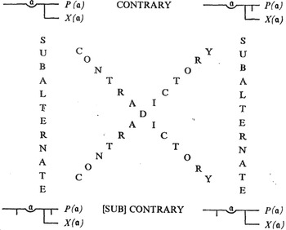

Despite its apparent symmetry with the Scholastic Square of Opposition, there are fundamental differences:
- Contraries can both be true (in the case where there exists no a that has the property Φ(ξ)).
- Subcontraries can both be false (in the same case).
- From A, I does not necessarily follow, and from E, O does not necessarily follow (cf. 1 & 2).

vii)
Finally, mention must be made of the shift effected by Gottlob Frege in the mode of analyzing propositions—from the Aristotelian tripartite scheme Subject–Copula–Predicate to the bipartite scheme Function–Argument. According to most scholars, this shift constitutes the very core of Fregean logic. This mode of analysis is influenced by mathematics and, in particular, by the notion of a function.
For example, the proposition “Man is mortal,” when analyzed in Aristotelian terms, consists of two autonomous terms (namely “man” and “mortal”) and the copula. According to Frege, by contrast, it consists of one autonomous term and one predicative expression that is not autonomous (namely “man” and “…is mortal”). The analogy with mathematical functions is evident. The expression “…is mortal” requires an argument in order to acquire meaning, and once supplied with one, it takes on a value (Truth or False). Correspondingly, the expression “x + 3” does not denote any specific number; to denote a number, the variable must be replaced by a determinate numeral.
It is clear that Frege’s innovation concerning quantification is directly connected with this innovation in the analysis of propositions. The expression “…is mortal” requires that its gap be filled by a variable, which must in turn be bound by a quantifier in order for the expression to acquire assertoric content. “x is mortal” is not something that can be affirmed or denied; by contrast, “for every x, x is mortal” does have assertoric content. The innovation in propositional analysis thus affords the same flexibility as the unrestricted use of quantifiers.
In Aristotelian syllogistic, no more than three terms can occur. In a Fregean argumentative form, the use of multiple quantification allows for as many “terms” as there are variables. Frege regarded this change as so fundamentally significant—and as so directly opposed to Aristotle—that already in §3 of the Ideography he explicitly notes:
“In my representation of judgment, the distinction between subject and predicate does not take place.”
***

Example of a Valid Argument Based on the Inferential Forms of the Ideography
Here we shall present an example illustrating how the axiomatic system of the Ideography operates. The example is the classical Stoic argument involving daylight and brightness. The premisses are:
- if it is day, then there is light;
- there is light.
The conclusion is: it is not day.
From the standpoint of syllogistic reasoning, this conclusion is unattainable—the argument belongs to propositional logic. According to the Stoic theory of hypothetical arguments, the conclusion follows immediately by a rule equivalent to modus tollens. In systems of natural deduction, it is likewise derived directly by modus tollens. In the Ideography, however, the derivation is somewhat more laborious.
Before presenting it, we note that the extended parallel line is called the “line of implication” (Schlusslinie; Ideography, p. 21) and indicates that what follows is inferred from what precedes.

The formula that appears at the beginning of the inferential form is a substitution instance of the fourth axiom of the Ideography. In contemporary proof systems it is also referred to as the rule of transposition. We substitute the antecedent with the first premiss, and after a uniform substitution of its variables throughout the entire formula, the consequent that results is the proposition “if it is not light, then it is not day,” which we then extract by applying modus ponens. We now take the second premiss together with the extracted consequent and, by applying the same modus, derive the desired conclusion.

Critique of Pure Reason, 2nd edition, p. VII.
Begriffsschrift, eine der Arithmetischen nachgebildete Formelsprache des reinen Denkens, Halle, 1879.
‘Über Sinn und Bedeutung,’ Zeitschrift für Philosophie und Philosophische Kritik, 100, 1892.
Grundgesetze der Arithmetik, Jena: H. Pohle, vol. I (1893), vol. II (1903).
For example, that of Ernst Schröder in Zeitschrift für Mathematik und Physik, 25, 1880.
The Principles of Mathematics, Cambridge University Press, 1903.
T. W. Bynum renders the term as “conceptual notation.”
Die Grundlagen der Arithmetik: Eine logisch-mathematische Untersuchung über den Begriff der Zahl, Breslau, 1884.
See the famous example of the proposition “7 + 5 = 12” in Critique of Pure Reason, 2nd edition, p. 15.
Ideography, p. V of the Introduction (Roman numerals refer to the Preface, Arabic numerals to the main text, following the German edition).
Ideography, p. 2.
The authorship of material implication is attributed to Philo of Megara; see Kneale & Kneale, p. 128 ff.
Ideography, p. 9.
Principia Mathematica, Cambridge University Press, vol. I (1910), vol. II (1912), vol. III (1913).
For this reason, modus ponens is also called the “rule of detachment.”
Sections 13–22.
Prior Analytics, 25b38.
Ideography, p. 24.
Ideography, p. 2.
The second schema of Chrysippus.
We further clarify that certain minor technical details have been omitted which would render the present inferential form consistent not only in spirit but also in letter with the Ideography.
$\left(p→q)⇔(¬q→¬p\right)$

