Διεθνής Βυθός

1872-77 HMS Challenger: Εντοπίζει στο βυθό πολυμεταλλικούς κονδύλους (polymetallic nodules) 1-20 εκ. διάμετρο.
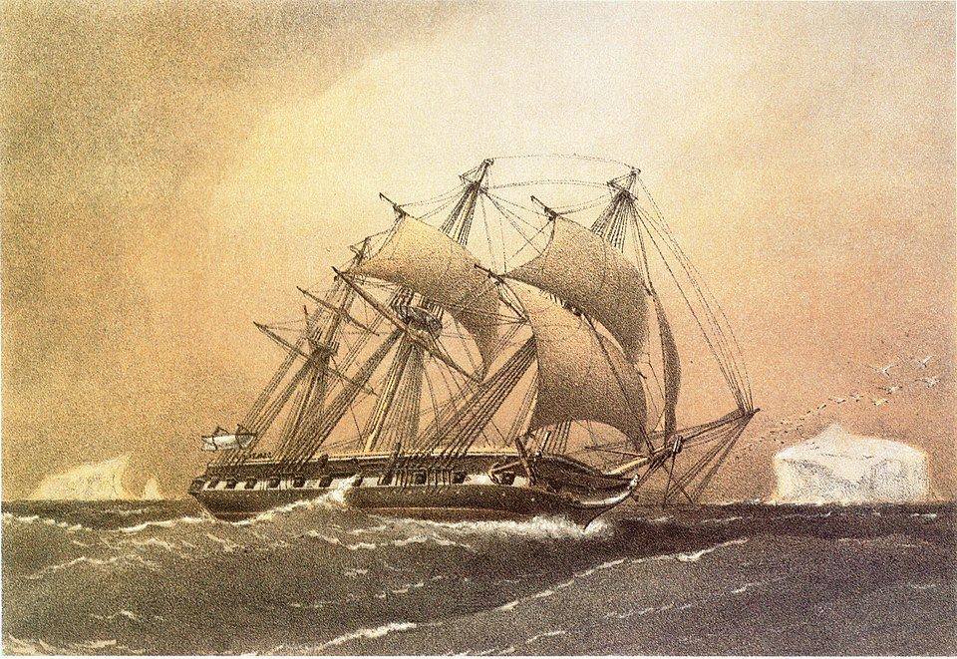

1958 Σύμβαση της Γενεύης:
- το σύνολο των υδάτων θα διαμοιραζόταν μεταξύ παράκτιων κρατών
- Res Communis
- Res Nullius
Παράλληλα τα αναπτυσσόμενα κράτη καλούν για μια νέα διεθνή οικονομική τάξη (NIEO)
1967: Arvid Pardo common heritage of mankind
1969: UNGA Res 2574:
- States and persons, physical or juridical, are bound to refrain from all activities of exploitation of the resources of the area of the sea-bed and ocean floor and the subsoil thereof, beyond the limits of national jurisdiction;
- No claim to any part of that area or its resources shall be recognized.

1970: UNGA Res 2749:
1. The sea-bed and ocean floor, and the subsoil thereof, beyond the limits of national jurisdiction (hereinafter referred to as the area), as well as the resources of the area, are the common heritage of mankind.
2. The area shall not be subject to appropriation by any means by States or persons, natural or juri­dical, and no State shall claim or exercise sovereignty or sovereign rights over any part thereof.
3. No State or person, natural or juridical, shall claim, exercise or acquire rights with respect to the area or its resources incompatible with the inter­national regime to be established and the principles of this Declaration.
4. All activities regarding the exploration and exploitation of the resources of the area and other related activities shall be governed by the interna­tional regime to be established.
5. The area shall be open to use exclusively for peaceful purposes by all States, whether coastal or land-locked, without discrimination, in accordance with the international regime to be established.

UNCLOS
Art. 136
The Area and its resources are the common heritage of mankind
Art. 137(1)
No State shall claim or exercise sovereignty or sovereign rights / no State or natural or juridical person shall appropriate any part thereof
Art. 140(1)
Activities for the benefit of mankind as a whole

International Seabed Authority
Συνέλευση: Plenary
Συμβούλιο: 36 μέλη
Γραμματεία: Γενικός Γραμματέας
Αρμοδιότητα ratione materiae στα ζητήματα που ορίζει η Συμφωνία του 1994 για την Εφαρμογή της Σύμβασης: Διοικητικά, Επιχειρησιακά, Οικονομικά, και ζητήματα εφαρμογής των αποφάσεών της
Ratione loci στο διεθνή βυθό

Το σύστημα εκμετάλλευσης

153(2)
Activities in the Area shall be carried out […]:
- by the Enterprise

- in association with the Authority by States Parties, or state enterprises or natural or juridical persons which possess the nationality of States Parties or are effectively controlled by them or their nationals, when sponsored by such States, or any group of the foregoing which meets the requirements provided in this Part and in Annex III
Τρία στάδια εκμετάλλευσης: prospecting, exploration, exploitation
Πώς ορίζεται η περιοχή εκμετάλλευσης;
- Ο φορέας εκμετάλλευσης (ή το συμβαλλόμενο μέρος – contractor) καταθέτει σχέδιο που περιλαμβάνει μια συγκεκριμένη περιοχή με έκταση ικανή προς εκμετάλλευση από δύο φορείς (22 συμβάσεις μέχρι στιγμής)
- Η Αρχή εντός 45 ημερών ορίζει ποιο μέρος θα εκμεταλλευτεί η ίδια. Το υπόλοιπο είναι προς εκμετάλλευση από τον συμβαλλόμενο
- Σε κάθε περίπτωση η Αρχή ασκεί έλεγχο
- Μπορεί να απορρίψει ή να ακυρώσει αιτήσεις α) για περιοχές όπου ήδη είναι υπό εκμετάλλευση από άλλον φορέα ή β) ο αιτών σχεδιάζει εκμετάλλευση και σε άλλη περιοχή όταν όποια από τις δύο ξεπερνάει σε εμβαδόν το 30% γύρω από το κέντρο μιας έκτασης 400.000 τετραγωνικών χιλιομέτρων.
Το ζήτημα της Συμφωνίας του 1994 και η θέση σε ισχύ της Σύμβασης ΔΘ
Σειρά ζητημάτων που τέθηκα από τα ανεπτυγμένα κράτη λύθηκαν από τη Συμφωνία
Ενδεικτικά
α) Δεν υπάρχει υποχρέωση χρηματοδότηση της Enterprise
β) Δεν υπάρχει υποχρέωση για μεταφορά τεχνογνωσίας
γ) Η Enterprise εξισώνεται με τους υπόλοιπους φορείς
δ) Δεν εφαρμόζονται οι διατάξεις για τις αρμοδιότητες της Συνέλευσης και του Συμβουλίου – το Συμβούλιο προτείνει στη Συνέλευση η οποία αποδέχεται ή επιστρέφει
ε) Οι ΗΠΑ αποκτούν μόνιμη θέση στο Συμβούλιο
Πώς εκμεταλλεύεται η Αρχή;
The Enterprise ο εκτελεστικός βραχίονας (δεν έχει συγκροτηθεί ακόμη)
Πώς εκμεταλλεύονται οι ιδιώτες;
Καταθέτουν αίτημα σε κράτος να είναι sponsor
Συνάπτουν σύμβαση με το κράτος και υποβάλλεται αίτηση
Ο φορέας υπογράφει σύμβαση με την ISA με standard terms of contract
Η σύμβαση διέπεται από τους όρους της, από τη Σύμβαση ΔΘ, από τους κανονισμούς της ISA, και από του σχετικούς κανόνες του διεθνούς δικαίου.
Αυτό δημιουργεί σειρά ζητημάτων ως προς το συμμερισμό της ευθύνης (shared responsibility) και της δικαιοδοσίας του ITLOS επί νομικών προσώπων.
The LOSC provides for a set of obligations that seeks to regulate the protection of the environment in the Area. These obligations operate on three levels. First, the states that sponsor an entity to undertake activities in the Area (exploration or exploitation) are under an obligation to protect and preserve the environment. The Advisory Opinion of the Deep Seabed Disputes Chamber on the responsibilities of sponsoring states in the Area confirmed the existence of this obligation. The Chamber added that this obligation consists of a number of direct obligations and of a more general due diligence obligation. Secondly, the International Seabed Authority is also under an obligation to take measures to protect and preserve the environment in the Area. This obligation is enhanced by the supervisory role of the ISA in relation to the Area.
The third level of application of these obligations concerns the sponsored entities that engage in activities in the Area. Any sponsored entity that seeks to engage in activities in the deep seabed must conclude a contract with the ISA. All contracts concluded between the ISA and the sponsored entities contain a number of standard clauses. These clauses transpose into the contract the regulations issued by the ISA and the relevant provisions of the LOSC. Both the regulations of the ISA and the standard clauses contain obligations that pertain to the protection of the environment on the part of the sponsored contractors. If these are read in conjunction with the LOSC that clearly stipulates the responsibility of the contractor if damage occurs in the seep seabed, it can be safely concluded that the contractors are indeed bound by international law to protect and preserve the environment in the deep seabed. The governing law of the contract also points to the same conclusion: Standard Clause 27.1 that posits that the governing law of the contract are the terms of the contract, the rules and regulations of the ISA, Part XI of the LOSC as well as other rules of international law.
In conclusion, most of these obligations are couched in similar terms for all actors involved but at the same time they rest on distinct legal bases. The sponsored entity will obviously be liable for the actual damage caused by the exploration activities in the deep seabed, while the sponsoring state will be liable for the breach of its own supervisory obligations. The ISA, on the other hand, may be liable for breach of either its supervisory and regulatory obligations or for breach of its emergency response obligations.

The Advisory Opinion of the Seabed Disputes Chamber of the ITLOS
The Advisory Opinion of the Seabed Disputes Chamber of the International Tribunal for the Law of the Sea (ITLOS) concerning the responsibilities and obligations of states sponsoring entities conducting activities in the Area is a significant development in the understanding of these duties under the United Nations Convention on the Law of the Sea (LOSC) and the 1994 Agreement relating to the Implementation of Part XI of the LOSC. The Republic of Nauru initiated the request for this advisory opinion due to concerns that its potential responsibilities and liabilities as a sponsoring state for Nauru Ocean Resources Inc.'s exploration for polymetallic nodules could exceed its financial capabilities. The Council of the International Seabed Authority subsequently formulated three questions for the Chamber.
These questions addressed the legal responsibilities and obligations of sponsoring states, the extent of their liability for failures by sponsored entities, and the necessary measures states must take to fulfil their responsibilities. Before addressing these questions, the Chamber clarified key terminology, defining sponsorship as requiring the sponsored entity to be a national of the sponsoring state or controlled by it or its nationals, and to be sponsored by that state. Activities in the Area were defined to include the recovery of minerals, lifting them to the surface, water evacuation, and preliminary separation, but not transportation to land from the high seas, unless such transport is directly linked to extraction from the seabed. The Chamber also clarified that the term 'responsibilities' in articles 139, 235, and Annex III article 4 of the LOSC signifies a primary obligation in international law, whereas in article 235(3) and Annex III article 22 it refers to a secondary obligation, with 'liability' denoting the consequences of breaching a primary obligation.
Regarding the responsibilities of sponsoring states, the Chamber focused on the concept of due diligence obligations. It interpreted the 'responsibility to ensure' in LOSC article 139(1) as an obligation of conduct, not result, requiring sponsoring states to ensure compliance by their contractors. The strictness of this obligation depends on the risk of the activity. The Chamber noted that states must adopt necessary measures in their legal systems to discharge this obligation, as indicated in article 139(2) and Annex III article 4(4) of the LOSC. These measures aim to ensure contractor compliance and exempt the sponsoring state from liability. While not providing specific advice, the Chamber suggested examples of such measures, including criteria on financial viability and technical capacity, and the establishment of enforcement mechanisms. Importantly, the Chamber stated that the direct obligations of sponsoring states provide a key indication of the content of their due diligence obligation.
The Chamber identified several direct obligations of sponsoring states. These include the obligation to assist the Authority through the exercise of due diligence, and the application of the precautionary approach, which the Chamber considered a binding obligation derived from the Sulphides and Nodules Regulations, effectively turning Principle 15 of the Rio Declaration into a legal norm in this context. The Chamber also mentioned the obligation to apply the best environmental practices, to provide for guarantees in case of emergency, and to provide for recourse to compensation.
A significant focus was placed on the obligation to conduct an Environmental Impact Assessment (EIA). The Chamber stated that sponsoring states have a due diligence obligation to ensure an EIA is undertaken, as per Section 1(7) of the Annex to the 1994 Agreement. This obligation is also considered a general obligation under customary law. Furthermore, the Chamber held that sponsoring states and contractors should establish monitoring programmes in cooperation with the Authority. Notably, the Chamber broadened the application of EIA to areas beyond national jurisdiction and asserted that the content of the EIA should be determined by the Authority's relevant Regulations and Recommendations, differing from the ICJ's view in the Pulp Mills case where national laws were considered definitive.
Concerning the extent of liability of sponsoring states, the Chamber stated that liability would be incurred if they fail to carry out their responsibilities, evidenced by a breach of their due diligence and direct obligations coupled with damage to the Area. The Chamber considered the requirement of damage an exception to general rules of state responsibility, inferred from article 139(2) of the LOSC. Potential claimants include coastal states, seabed mining entities, other sea users, and the Authority acting on behalf of mankind. The Chamber also posited that any State party could be a claimant given the erga omnes obligation to preserve the environment. A causal link between the sponsoring state's failure and the damage must be proven, with no presumption of its existence.
The Chamber found that sponsoring states are not liable when a sponsored contractor breaches their obligations and causes damage, provided the state has fulfilled its own responsibilities. It also clarified that the LOSC does not provide for joint and several liability, but rather parallel liability for both the contractor and the state if both breach their obligations. A significant issue identified by the Chamber is a 'gap' in the liability regime in cases where damage occurs despite the sponsoring state fulfilling its obligations and the contractor failing to meet theirs. To address this, the Chamber proposed that the Authority consider setting up a fund for damages, similar to those in oil pollution and nuclear energy regimes. Finally, the Chamber stated that when damage occurs, there is a duty for full compensation or restitutio in integrum, although the form of reparation may depend on the technical feasibility of restoration.

